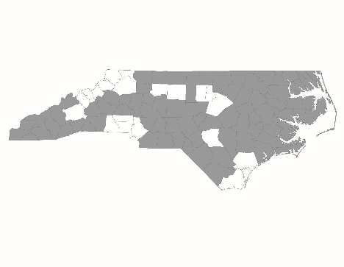


NC Balance of State CoC Steering Committee
Meeting Minutes
July 11, 2023
Regional Leads Present: Derek Lancour, Emily Lowery, Amber Story, Pamela Hinton, Kristen McAlhaney, Natasha Elliott, James Stroud, LaTasha McNair, Kisha Darden, Tujuanda Sanders, Brian Fike
At-Large Members Present: Rachelle Dugan, Ellen Blackman, Brooks Ann McKinney, Cassandra Rowe, Angela Harper King, Beth Branagan, Catherine Kastleman
SC Members Absent: Tiffany Askew, Marie Watson, Emily Locklear
Interested Parties Present: Shanta Watkins, Lori Watts, Shelly Chandler, Kecia Robinson, Teena Willis, Kerry Bashaw, Mark Kobelinski, Erin Gaskin, Michael Absher, Bre Griffin, Monica Frizzell, Leah Dyson, Sarah Lancaster, Kim Hemphill, Michele Welsh, Shantisha Williams, Clementine Thompson
NCCEH Staff Present: Brian Alexander, Laurel Benfield, Allie Card, Adriana Diaz, Jenny Simmons, Ashley VonHatten
Approval of Consent Agenda
- The consent agenda was sent out for review prior to the meeting and is posted at: https://www.ncceh.org/bos/steeringcommittee/
- The consent agenda was voted on at the beginning of the meeting. Without changes or objection, the consent agenda was approved by common consent.
Letter of Support Request
Rowan Helping Ministries has requested a letter of support from the NC BoS CoC for its Supportive Housing American Rescue Plan (SHARP) grant application.
The North Carolina Housing Finance Agency received $6.5 million in HOME-American Rescue Plan (HOME-ARP) funds through the American Rescue Plan Act of 2021. Funds assist people experiencing homelessness, those at risk of becoming homeless and other vulnerable populations. These funds are intended to reduce homelessness and housing insecurity and may be used to develop rental housing and non-congregate shelter, provide supportive services or offer tenant based rental assistance. Rowan Helping Ministries is requesting a $750,000 15-year fully forgivable loan and includes capitalized operating expenses, which would create Permanent Supportive Housing (PSH) units for citizens needing affordable rental housing and supportive services to end homelessness and housing insecurity.
- Eight 1-bedroom and two 2-bedroom PSH units will be built on vacant land owned by Rowan Helping Ministries.
- Outdoor green space with a gathering area, a raised-bed community garden, adjacent tenant parking, solar panels, and other environmentally friendly features to enhance energy savings.
- The PSH project is $2,333,000 as part of a tri-phase $6 million capital campaign. Construction will begin once funding is secured, with completion no later than December 2027.
James Stroud made a motion to approve Rowan Helping Ministries’ letter of support request. Rachelle Dugan seconded the motion. The motion passed unanimously.
NCORR Back@Home – Balance of State Request for Applications (RFA)
The Special CoC Program NOFO Funds will form the backbone for Back@Home-Balance of State. The Back@Home Initiative is a collaborative rehousing initiative of state & local partners to:
- Assist households stabilize through access to permanent housing, adequate income, and appropriate support & services.
- Addresses these needs through a combination of financial assistance & housing stabilization services
Back@Home BoS builds on lessons learned from prior iterations of Back@Home:
- Back@Home-Disaster
  - Initiated during Hurricane Florence
  - September 2018 – June 2022
- Back@Home-CV
  - Using ESG-CV funding during the pandemic
  - August 2020 – September 2023
- Back@Home-BoS
  - Target launch date October 1, 2023
Back@Home-BoS will use a centralized approach to provide rehousing services to all 79 counties in the CoC:
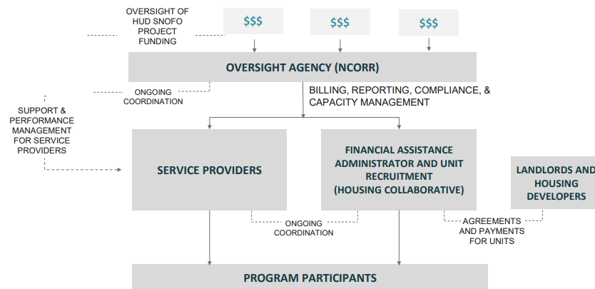

The North Carolina Office of Recovery & Resiliency (NCORR) issued a Request For Applications (RFA) to select Regional Service Providers on June 19. Regional Service Providers play an essential role in the B@H-BoS program. The RFA calls for Regional Service Providers to develop a Rehousing Support Team model that would provide these essential services:
- Outreach
- Housing Stabilization Case Management
- System Navigation
- Housing Navigation
NCORR will award contracts to build rehousing capacity across the CoC’s 79 counties. Selections will prioritize agencies providing expanded county coverage.
- RSPs will contract directly with NCORR to provide services.
- NCORR will provide a Per Member Per Month (PMPM) rate of $400.26 per household served
  - Anticipated average contract for the 3-year period: $720,468
  - Rehousing teams selected will have at least 2 staff members
  - Estimated household to case manager ratio will be 1:25
- Eligible applicants:
  - Nonprofit organizations
  - Local government agencies
  - Public housing authorities
  - Native American tribal organizations
All RFA information has been posted on the NCORR website: www.rebuild.nc/gov/contractors/requests-applications. All application materials are due on July 21, 2023, at 11:59 P.M. Questions can be sent to housing.stability@ncdps.gov.
FY2023 CoC Program Competition
CoC staff shared the following project application information:
- Renewal Project Application Information
  - Pre-Competition Scoring and Standard Review is complete.
    - All Renewal Projects met all standards for either PSH or RRH for a 3-year certification either starting in FY2023 or FY2024!
  - The Grant Inventory Worksheet (GIW) review is complete.
    - The GIW was received on June 13th from HUD and was sent to Renewal Applicant providers that afternoon.
    - The GIW was correct and returned to HUD before the deadline of June 28th.
- FY2023 CoC Program Notice of Funding Opportunity Released July 5, 2023, on grants.gov and sent out via email from the HUD Exchange mailing list late yesterday afternoon.
- Final Project Applications due to HUD by September 28, 2023.

All application materials and instructions have been posted at: https://www.ncceh.org/bos/currentcocapplication/.

CY2024 Emergency Solutions Grant Competition
The RFA was released on June 6. A webinar for all Project Applicants was held on June 22.
- Recorded webinars and competition materials are available at www.ncceh.org/bos/esg.
Project Applications were due to NCCEH by 5:00 PM on July 12. The total amount available for the NC BoS CoC in the CY2024 Emergency Solutions Grant (ESG) competition is $2,525,734. CoC staff shared the Regional Fair Share:
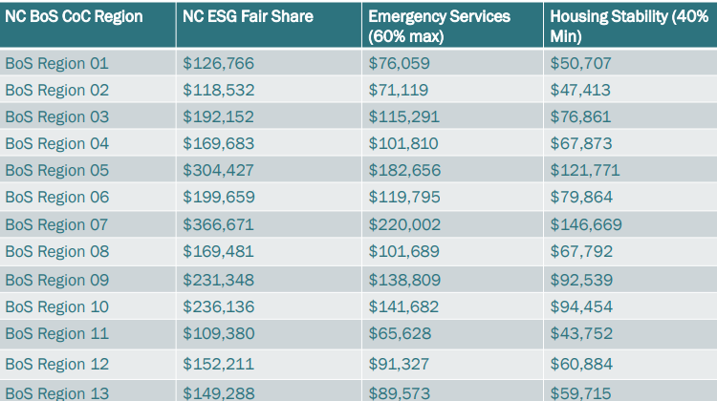

The ESG competition timeline is as follows:
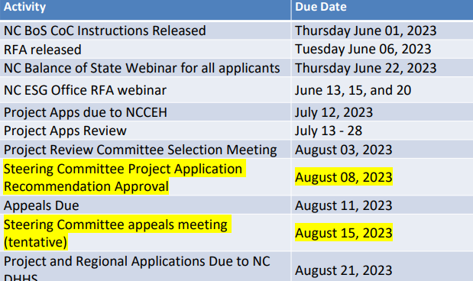
Any applications received after 5:00 PM on July 12, 2023, are not guaranteed to be reviewed.
At-Large Steering Committee Seat Vacancy
An at-large SC seat has opened mid-year. Jeffrey Rawlings stepped down from the Steering Committee when he took a new position outside the NC BoS CoC. His at-large seat is open for the remainder of the year.
The term would be from August to December 2023. The seat is reserved for person with lived experience of homelessness (PLE) and is not restricted to one region of the CoC.
In the past, if an at-large seat opens mid-year, it is filled by someone in the same agency that employed the departing member. This precedent doesn’t apply in the case of PLE seats. Jeffrey was a member of the Lived Expertise Advisory Council (LEAC). To fill this seat, the LEAC would propose nominating another subcommittee member to serve the remainder of the term.
The LEAC nominated Melissa Hewitt, one of the original members of the LEAC and serves on the Funding and Performance Subcommittee as well. She presented at the NC Bringing It Home Conference in 2023, alongside other members of the LEAC, and been instrumental in drafting the Client Bill of Rights. She has an Associates Degree in Business and lives in Hickory, NC. She has lived in her home since 2014 and is passionate about her family, both biological and chosen. She has been known to occasionally get on her soap box and is committed to impacting domestic violence atrocities and injustices against the homeless.
James Stroud motioned to approve Melissa Hewitt to fill the vacant at-large seat. Kisha Darden seconded the motion. The motion passed unanimously.
Veteran Subcommittee Update – Framework to End Veteran Homelessness in the NC BoS CoC
The NC BoS CoC Veteran Subcommittee re-launched in February 2023 to work toward a Framework to End Veteran Homelessness across the NC BoS CoC. The framework designs and implements a system to address Veteran homelessness in the CoC. Subcommittee membership includes SSVF grantees, VA Medical Center staff, HUD-VASH staff, other Veteran service agencies, and Veterans with lived experience of homelessness.
- Framework goal: Every Veteran experiencing homelessness in the NC BoS CoC is quickly connected to permanent housing and appropriate services to maintain housing. Created by the Veteran Subcommittee, the framework will outline key system components to be implemented on a regional and service provider level to reach the stated goal above.
- Framework Core Components
  - System Flow - Ensuring Veterans facing homelessness across the NC BoS CoC have a clear and accessible path toward permanent housing.
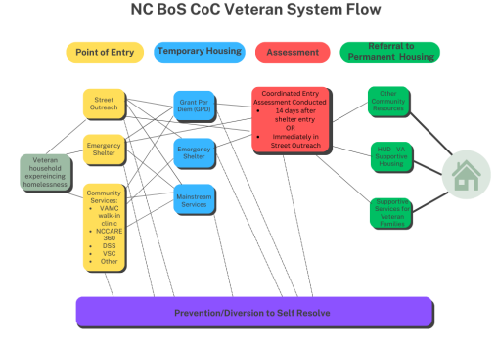
  - Centering Equity - Centering Equity is a key component to the Framework to End Veteran Homelessness due to the importance of elevating historical racism and systems built on white supremacy. We must better understand how these systems disproportionately impact BIPOC Veterans and strategize approaches to create lasting change.
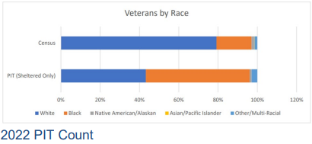
  - Coordinated Entry Integration - All Veterans experiencing homelessness in the NC BoS CoC should be served through their regional Coordinated Entry (CE) system to be swiftly housed. Four elements are essential to the coordinated entry system.
    - For full integration, regional CE systems should incorporate the following Veteran specific practices:
      - Regularly hold case conferencing meetings inclusive of Veteran-specific conversations and resources.
      - Run and provide Veteran by-name list data at every meeting.
      - Swiftly connect Veterans deemed ineligible for Veteran-specific resources to civilian resources.
  - Provider Coordination: Roles & Expectations - It’s important for each partner providing services to Veterans to agree to a standard and specific set of roles & expectations to be effective.
    - Veteran Service Providers (includes SSVF, HUD-VASH, GPD, HCHV, VAMC Outreach, etc.) will:
      - Attend case conferencing meetings
      - Communicate regularly with other providers serving Veterans experiencing homelessness
      - Educate themselves and other community providers regarding other Veteran resources and programs
      - Complete CE assessments and make referrals to the regional by-name list, as needed
      - Report housing outcomes for referred households to the CE Lead at case conferencing meetings
    - Regional CE Leads will:
      - Facilitate Veteran-specific case conferencing monthly
      - Run the Veteran BNL in preparation for each case conferencing meeting
      - Facilitate referrals of eligible Veterans to SSVF and HUD-VASH
  - Addressing System Gaps - Currently, the NC BoS CoC homeless response system has various gaps to overcome to better serve Veterans experiencing homelessness. Below are the main themes of such gaps, as well as approaches the CoC should take to address them.
    - Build trust and communication between providers
    - Expand program knowledge
    - Share Data
    - Conduct system analysis, evaluation, and accountability
  - Key Performance Indicators & Data Analysis - Systems must regularly analyze performance to measure success toward established goals. Below are key performance indicators the Veteran Subcommittee will monitor on a quarterly basis. Baseline data is provided to measure change overtime.
    - Overall Veteran representation
      - 2023 Point in Time Count: 191 total Veterans experiencing homelessness across the NC BoS CoC; 136 sheltered, 55 unsheltered.
      - Goal: 20% decrease of overall Veteran homelessness and unsheltered Veteran homelessness from 2023-2025.
    - Length of time homeless
      - 2022 HMIS Data: Veterans enrolled in ES, TH, RRH, and PSH projects spent an average of 123 days homeless.
      - Goal: Decrease average days Veterans experience homelessness to 115 days by 2025.
    - Race/Ethnicity demographics and outcomes
      - 2022 HMIS Data: 51% of Veterans served in ES, TH, RRH, and PSH projects were Black/African American; 39% permanently housed were Black/African American.
      - Goal: Increase permanent housing placements for Black/African America Veterans to 50% by 2025.
    - Exits to permanent housing
      - 2022 HMIS Data: percentage of Veterans served in ES, TH, RRH, and PSH projects permanently housed was 41%.
      - Goal: Increase percentage of Veterans permanently housed to 55% by 2025.
    - Returns to homelessness
      - 2021 HMIS Data: the percentage of Veterans returning to homelessness within 1 year after a permanent housing exit was 4%.
      - Goal: Decrease the percentage of Veterans returning to homelessness within 1 year to 2% by 2025.
CoC Leadership Workshop Debrief
On Thursday, June 15, 2023, CoC Leadership met for an in-person workshop. The focus of the workshop was on year-round unsheltered access coordination. The agenda included:
- An overview of roles and responsibilities
- Breakout groups to create system mapping for each region
- Breakout groups to deep-dive into county-by-county support for connecting persons living unsheltered to services, shelter, coordinated entry, and permanent housing
- Report-outs from each region (to learn from our peers!)
Regional system mapping
- Each Regional Unsheltered Coordination Workbook includes a list of known regional projects broken down by agency, funding, and HMIS participation.
- Regional leaders used this list to identify the organizations, entities, and volunteer initiatives that provide services and housing to people experiencing unsheltered homelessness in each county.
- Regions also identified any gaps that exist in each county that the Regional Committee will need to address as part of their plan.
The Outreach Planning section was broken into two parts.
- Assertive outreach means outreaching and engaging people experiencing unsheltered homelessness where they gather.
- Passive outreach happens with other community stakeholders, focusing on outreaching and engaging providers to connect to people experiencing unsheltered homelessness.
- Regions were asked to identify agencies in each county to do on-going assertive and passive outreach.
System Navigation Planning
- System navigation services assist people experiencing unsheltered homelessness with accessing resources from the homeless service and partner systems to obtain permanent housing.
- Regions should ensure that the local system has a plan to continue providing basic and higher-level services to people experiencing unsheltered homelessness identified through outreach efforts.
- Regions were asked how they will ensure those living unsheltered do not get lost in the homeless response system.
Training & Evaluation Planning
- To prepare collaborative partners to work closely with people experiencing unsheltered homelessness, the region needs to plan how it will provide training and ongoing technical assistance.
- Regions were also tasked with determining a process to gauge the effectiveness of the Unsheltered Access Coordination Plan.
Next steps:
- Every region received a digital copy of the workbook.
- Share the completed document with regional partners & schedule time on the next Regional Committee meeting to discuss the plan, gather feedback, answer questions, & build buy-in
- Update the document with feedback from regional stakeholders
- Submit the final Unsheltered Access Coordination Plan to bos@ncceh.org by end of July
Upcoming meetings & reminders
- Funding and Performance Subcommittee, Thursday, July 27, 11:00 A.M. – 12:00 P.M.
  - Presentation: https://meet.google.com/dep-rjxz-kze
Or dial: (US) +1 442-272-1109
PIN: 883 218 555#
- Unsheltered Access Coordination Meeting, Thursday, August 3, 3:00 – 4:00 P.M.
  - Presentation: https://us06web.zoom.us/j/5799039481?pwd=UFkwNCtLdUszeG94Y2prS0ttRkVmdz09
Meeting ID: 579 903 9481
Passcode: qYqVY5
- Veteran Subcommittee Meeting, Monday, August 7, 11:00 A.M. – 12:00 P.M.
  - Presentation: https://us06web.zoom.us/j/83432109941?pwd=djRCOHVDWjVjVHNFWi8rTGNrTng1Zz09
Meeting ID: 834 3210 9941
Passcode: 624311
- HMIS System Updates, Tuesday, August 8, 10:30 – 11:30 A.M.
  - View recording at: https://www.ncceh.org/hmis/news/
- Lived Expertise Advisory Council Meeting, Friday, August 11, 12:00 – 1:00 P.M.
  - Presentation: https://zoom.us/j/5799039481?pwd=UFkwNCtLdUszeG94Y2prS0ttRkVmdz09
Meeting ID: 579 903 9481
Passcode: qYqVY5
- Racial Equity Subcommittee Meeting, Wednesday, August 16, 11:30 A.M. – 12:30 P.M.
  - Presentation: https://us06web.zoom.us/j/83264838597?pwd=TzVCWTM4WXdvSVJqbDVlR1I0NnMrUT09
Meeting ID: 832 6483 8597
Passcode: 023622
- Coordinated Entry Council, Monday, August 21, 10:00 A.M. – 11:30 A.M.
  - Presentation: https://us06web.zoom.us/j/84840397905
Meeting ID: 848 4039 7905

Next Steering Committee meeting
ESG Appeals Meeting: Tuesday, August 15, 10:30 – 11:30 A.M.
CoC Ranking List Approval Meeting: Tuesday, August 22, 10:00 – 11:00 A.M.
CoC Appeals Meeting: Tuesday, August 29, 10 A.M. – 11 A.M.

NEXT REGULAR STEERING COMMITTEE MEETING:
Tuesday, August 8, 2023, at 10:30 A.M.

