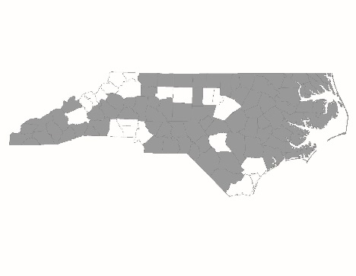


NC Balance of State CoC Special Steering Committee
Meeting Minutes – CoC Project Ranking
August 22, 2023
Regional Leads Present: Derek Lancour, Emily Lowery, Amber Story, Pamela Hinton, Kristen McAlhaney, Natasha Elliott, Dr. Dia Thomas, LaTasha McNair, Kisha Darden, Catonnia Pitt, Brian Fike
At-Large Members Present: Melissa Hewitt, Rachelle Dugan, Ellen Blackman, Catherine Kastleman, Angela Harper King, Lisa Phillips
SC Members Absent: Tiffany Askew, Brooks Ann McKinney, Cassandra Rowe, Marie Watson, James Stroud
Interested Parties Present: Akeem McDuffie, Christina Rary, Casey McCall, Bre Griffin, Crystal Gwendo, Denice Ariztia, Kerry Bashaw, Kristine Wiles, Laurenn Singleton, Leah Dyson, Mary Erwin, Shaneitha Lee, Veronica Murphy, Zinia Holley, Alyce Knaflich, Teena Willis, Lori Watts, Amy Modlin, Melissa Elliott
NCCEH Staff Present: Brian Alexander, Laurel Benfield, Allie Card, Jenny Simmons, Ashley VonHatten
Scoring Process/Project Applications
The CoC Consolidated Application has 3 parts
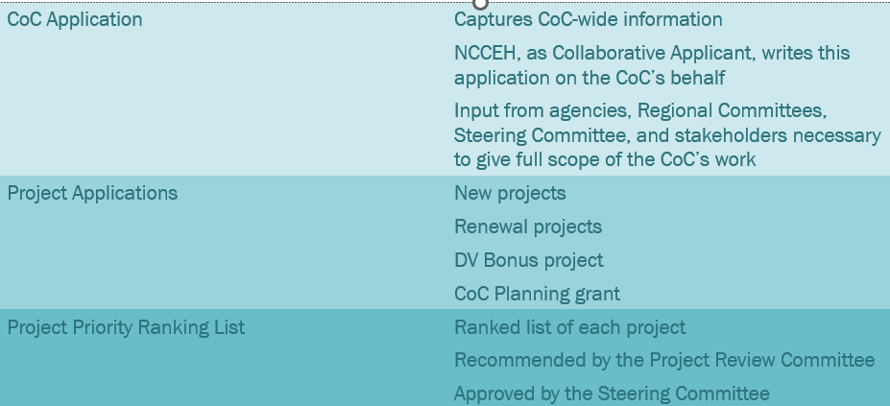
The Project Review Committee plays a crucial role in the application process.
- Composed of one representative from each Regional Committee & interested at-large Steering Committee members (conflict-free -- not grantees or applicants)
- Scores new & renewal project applications using approved scorecards
- Recommends ranked list of new & renewal project applications for CoC Collaborative Application to the Steering Committee for approval
Scoring & ranking projects allows the CoC to prioritize funding for the best projects. The scoring and ranking process:
- Allows the CoC to prioritize funding based on HUD & CoC priorities and needs
- Ensures the CoC prioritizes funding for projects that have high performance & manage funds well
- Required by HUD
The CoC has over $16.6 million in homeless funding at stake in the FY2023 CoC Program competition.
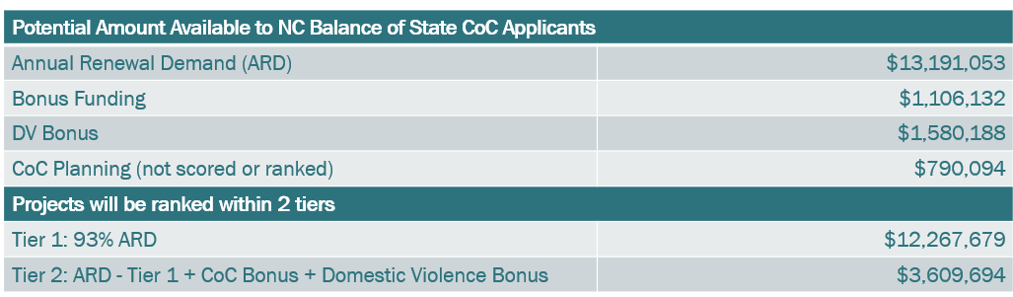
Project ranking was informed by the CoC’s Funding Priorities & the scorecards. The FY2023 CoC Program Funding Priorities document provides guidance from the Continuum of Care on its priorities for funding. This includes priorities for funding specific project types and regional needs.
The approved new & renewal scorecards organize evaluation using:
- Thresholds: Essential components that must be met in order to be funded.
- Standards: High priorities for projects to ideally meet that indicate programmatic success.
- Minimums: Meeting section minimums indicates well-rounded projects and that essential components are not missing that could affect performance.
- Points: Used to incentivize practices and to pull higher performing projects up in the ranking list.
The PRC & NCCEH staff used approved scorecards to review applications.
- Two Types of Scoring:
  - Combined Scoring section of each application scored by:
    - One member of the PRC
    - One member of NCCEH staff
    - Combined Scoring section scores are averaged.
    - Threshold & standards discrepancies are reconciled by an additional staff member.
  - Staff Scoring section scored by NCCEH staff
  - Combined Scoring + Staff Scoring = Total Score

FY2023 CoC Application Summary
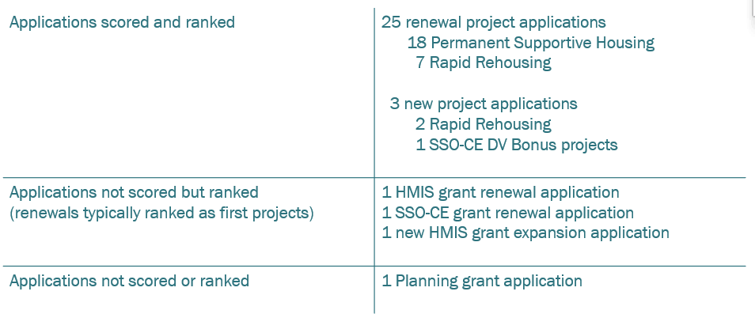
Renewal Project Scoring Overview
Renewal project summary:
- 27 renewal projects turned in applications.
  - (1) HMIS project (not scored)
  - (1) SSO-Coordinated Entry project (not scored)
  - (18) Permanent Supportive Housing projects
  - (7) Rapid Rehousing projects
- Scored renewal projects:
  - (0) applications with threshold issues
  - (16) applications were late or missing submission materials (Standard)

Renewal applicants missed a range of standards.
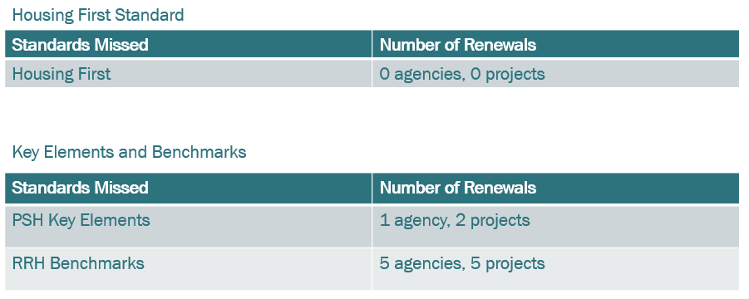
New Project Review
Four new projects turned in applications.
- (2) Rapid rehousing projects
- (1) HMIS expansion project
- (1) DV Bonus project
  - (1) SSO-CE
New project comparison
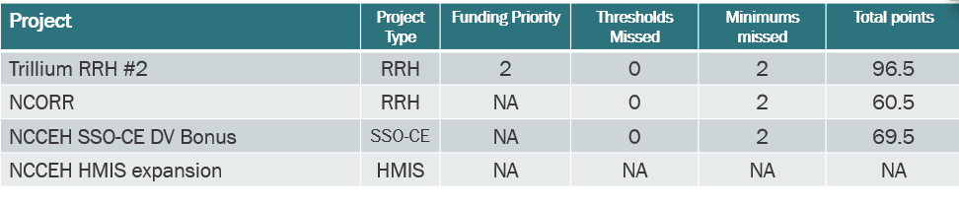

Most new applicants met all key thresholds and standards.
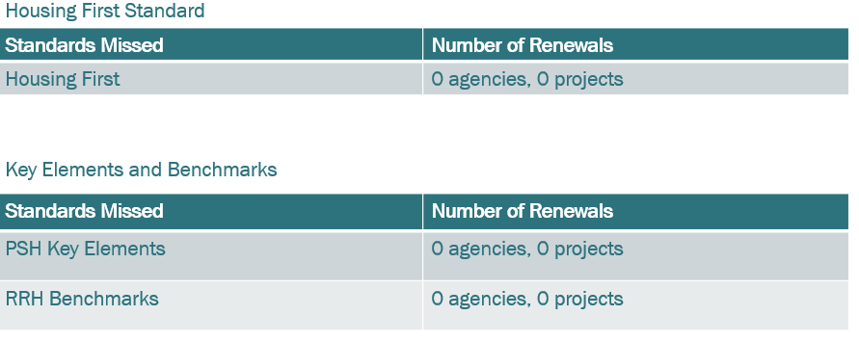
Ranking Options
The PRC used timeliness & historical precedent to order the final ranking list.
The Project Review Committee used the timeliness & completeness standard as the first way to order renewal projects in the ranking list.
- 8 agencies with 16 projects submitted incomplete or late materials.
The Project Review Committee also used several historical precedents including some key standards to order the final ranking list.
- Program Design Elements
  - Key Elements of Permanent Supportive Housing
  - USICH Rapid Rehousing Benchmarks
- Anti-Discrimination Policy adherence
Precedent 1: Infrastructure applications
- CoC precedent is to rank the NC BoS CoC HMIS and Coordinated Entry renewal applications at the top of the ranking list.
  - Protects required infrastructure
  - Funding Priorities document prioritizes infrastructure grants
Precedent 2: DV Bonus applications
- CoC precedent is to rank DV Bonus projects at the bottom of the ranking list.
  - One application with far ranging impacts for DV survivors
    - NCCEH Supportive Services Only – Coordinated Entry
  - Size could eliminate other projects, if higher in the ranking list
Precedent 3: Use Program Design Standards & Anti-Discrimination Policy Standards to order renewal projects.
- Pull up projects in groups for the number of Key Elements of PSH or RRH Benchmarks met
  - Group by standards met and then ordered by point total
- Pull down projects missing the Anti-Discrimination Policy standard
  - One agency with three projects
    - Community Link: Northern PSH, Piedmont 1 PSH, and PRC RRH
The PRC decided to reallocate the Community Link RRH renewal project due to performance & standards issues.
- The Project Review Committee reallocated the Community Link RRH renewal project due to:
  - Lowest scoring renewal project that was in operation for at least one year
  - Missed 4/15 RRH program standards
  - Missed Anti-Discrimination Policy adherence standard
  - Low performance scoring
  - Last renewal project on the ranked list with overall score lower than comparable new RRH applications
The PRC used the FY2023 CoC Program Funding Priorities document how to order & choose new projects for the ranking list.
- Per funding priorities, the PRC ranked the NCCEH HMIS expansion project as the first new project in Tier 2.
- Maintaining infrastructure is a top priority for the CoC
- The NC BoS CoC has had a funding shortfall for the last two years to pay the HMIS Lead for access to HMIS@NCCEH.
  - NCCEH has filled this gap with returned annual ESG and ESG-CV funding, but these resources will not be available moving forward.
  - The CoC needs a sustainable resource to pay for increased HMIS costs.
  - The CoC has not increased the amount of HMIS since the original grant was awarded.
- The PRC chose to include the NC Office of Recovery & Resiliency RRH project as the final new project in the ranking list.
- Met all RRH Program Standards & Anti-Discrimination Policy
- Covers all 79 counties in the CoC
- Ability to bring housing & healthcare leverage, which will add points to the CoC Consolidated Application, increasing the chances of more Tier 2 awards
- Adds capacity to Back@Home Balance of State rehousing program
- Includes Regions 5 & 11
  - New Trillium RRH #2 project application to cover R11 not included in the ranking list
  - Renewal Community Link RRH project application to cover R05 not included in the ranking list
The PRC final Tier 2 ranking list includes two new projects.
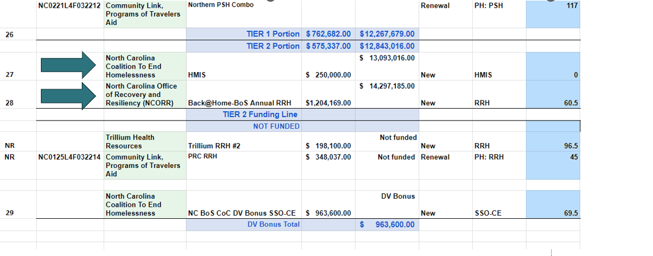
Final Recommended Prioritization Ranking List
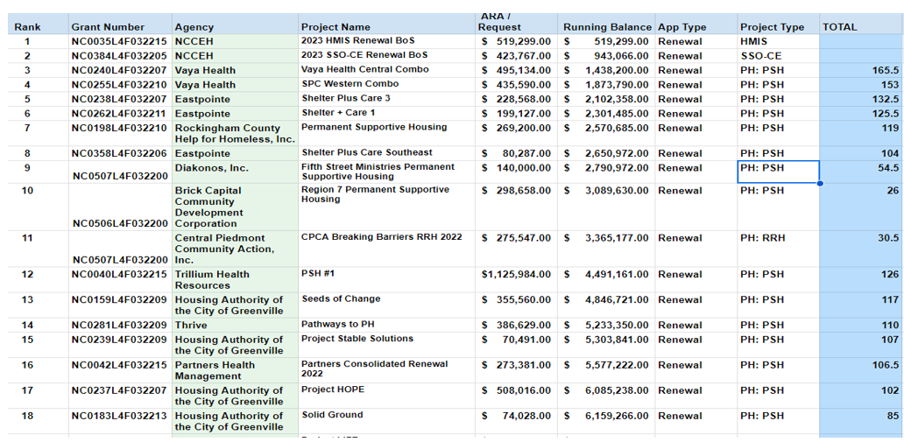
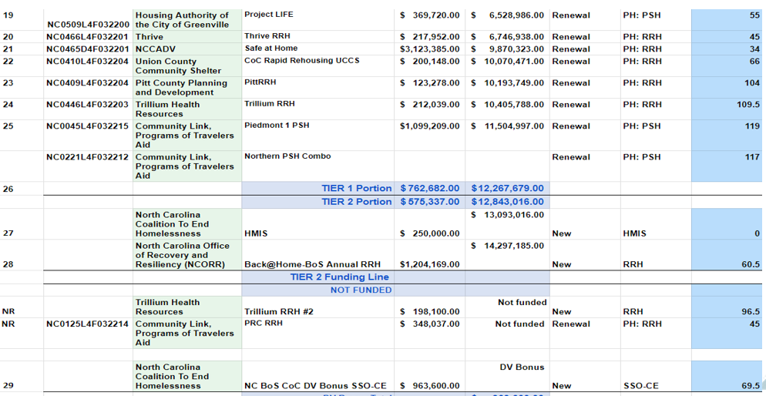

- The first 11 projects met the timeliness standard and were pulled up.
- 25 & 26 were pulled down as they did not meet the Anti-Discrimination Policy standard.

Questions:
- Derek Lancour requested to go back 1 slide to view the first half of the ranking list.
- Alyce Knaflich – should the amounts for Community Link be zero? Answer – this is an internal document and amounts are listed for reference.
Dr. Dia Thomas moved to accept the NC BoS CoC PRC’s recommended prioritization ranking list for the FY23 CoC Competition. Lisa Phillips seconded the motion. The motion was unanimously approved.

Next Steps: Notification & Appeal Process
Staff will notify applicants regarding decisions by the end of the day.
- Staff will send scorecards to applicants & offer follow-up calls after the competition.
- Applicants whose projects were not included in the final Prioritization Ranking List can appeal decisions.
Appeals Process
- Appeal documentation due to NCCEH by Thursday, August 24th at 12 PM
- If appeals are submitted, the PRC will meet on Friday, August 25th to consider information.
- If the PRC recommends overturning a decision, the Steering Committee will consider approval of an updated prioritization ranking list on Tuesday, August 29th at 10:30 AM.

Next Steering Committee meeting
[TENTATIVE] CoC Appeals Meeting: Tuesday, August 29, 10:30 – 11:30 A.M.

NEXT REGULAR STEERING COMMITTEE MEETING:
Tuesday, September 12, 2023, at 10:30 A.M.

