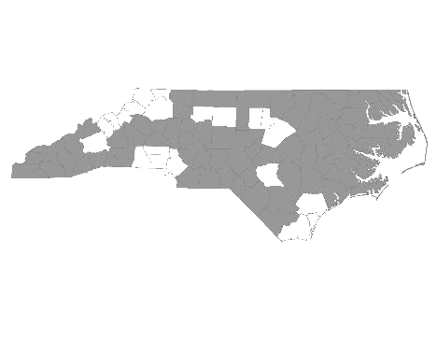


Davie-Iredell-Stokes-Surry-Yadkin (DISSY) Regional Committee

Meeting Minutes
Tuesday November 13, 2018 - 10:00 am
Location: 200 Elkin Business Park Dr. Elkin, N.C. 28621

Those present were:

Cynthia Cothren - The Ark
Michele Knapp - Fifth Street Ministries
Mary Adams – Yadkin County DSS
Debbie Hunter – Surry County DSS
Maxine Manley – Salvation Army SSVF
Brian Smith – SHAHC
Mollie Thompkins – Partners BHM
Teena Willis – Partners BHM
Donna Dean-Aguayo – Salvation Army SSVF

Teena Willis called the meeting to order and welcomed everyone. Teena made a motion to accept the minutes from October 9, 2018, Michele Knapp seconded the motion and it was approved.

We then received updates from the following agencies that provide services to the homeless within the five county region:

- Diakonos, Inc. dba Fifth Street Ministries - Fifth Street served 125 single individuals
and 10 families. They are still accepting referrals. My Sister’s House, battered women’s shelter, served 18 women and 16 children. The Veteran’s Transitional Housing Program is currently full. All services offered by Fifth Street Ministries are available to anyone within the five county region.
HOME of Mooresville currently has three families. They serve single women and children from Mooresville.

- DISSY Rapid Rehousing -There are currently 5 families and 1 single in housing. Please send in the VISPDAT before filling out the full application. Rapid Re-Housing is open to individuals on a case by case basis.

- The Ark – Has 4 single openings and one family opening. They serve families and single women who are not victims of domestic violence.

- SHAHC – Program is full at this time..

- Goodwill NWNC SSVF- Has funding and is taking referrals.

- Workfirst Surry Co. – Open to applications for families with children under 18.

It was noted that Helping Hands of Mount Airy may benefit by participating in these meetings. This program was started by a high school senior and gives out food and clothing to those in need. Someone will reach out.

Please reach out to other agencies that will benefit from these meetings. We need more participation.

With no further business, the meeting was adjourned.

The next meeting will be Tuesday, December 11th, 2018 at 8:30 A.M. at Fairfield Inn.

Respectfully submitted, Michele Knapp

