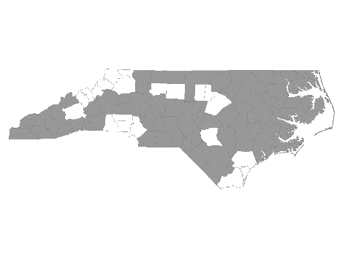


Davie-Iredell-Stokes-Surry-Yadkin (DISSY) Regional Committee
Meeting Minutes
Tuesday September 11, 2018 - 10:00 am
Location: 200 Elkin Business Park Dr. Elkin, N.C. 28621

Those present were:

Kevin Hege – Veteran Service Rep Surry Co.
Cynthia Cothren - The Ark
Michele Knapp - Fifth Street Ministries
Debbie Owen - Fifth Street Ministries, DISSY Rapid Rehousing Coordinator
Brian Smith - SHAHC
Mary Boyles - Shepherd’s House
Janet Carlton - Goodwill CC
Sara Lewis – United Way Iredell Co.
Sandra Johnson – DSS Surry (on conference)

Kevin called the meeting to order and welcomed everyone. Brian made a motion to accept the minutes from August 14, Cynthia seconded the motion and it was approved.

We then received updates from the following agencies that provide services to the homeless within the five county region:

- Diakonos, Inc. dba Fifth Street Ministries - Fifth Street served 131 single individuals
and 8 families. They are still accepting referrals. My Sister’s House, battered women’s shelter, served 19 women and 28 children. The Veteran’s Transitional Housing Program is currently full. All services offered by Fifth Street Ministries are available to anyone within the five county region.
HOME of Mooresville currently has two families. They serve single women and children from Mooresville..

- DISSY Rapid Rehousing -There are currently 4 families and 1 single in housing. Two families will be graduating the program the end of September. Please send in the VISPDAT before filling out the full application. Rapid Re-Housing is open to individuals on a case by case basis.

- The Ark - Currently serving 8 children and 13 adults. They serve families and single women who are not victims of domestic violence. They are looking to hire a new day manager, and have recently hired a housing coordinator.

- SHAHC – Currently in process of housing a single individual. Has 14 units full at this time. All clients in the program except one have secured disability.

- Shepherd’s House - Served 15 adults and 9 children. In the process of hiring a development director as well a case manager.

- United Way Iredell- Walk for Recovery is scheduled for September 28, 5:00-8:00 pm.

- DSS Surry – Serving families from crisis program. Assisted families with power bills during periods of extreme heat.

- Goodwill CC - Having a workshop on hidden resources in Surry Co. Sept. 25 from 3:00-4:00.
Is also sponsoring mock interview and employability workshops starting Oct. 2.
Contact Goodwill Career Connections for more information. (336-526-2144)

- Kevin – Took position as Veteran Service Rep in Surry Co. Provides numerous services to vets including securing benefits and pensions. Continuing to work toward a shelter for single males, including veterans in the Elkin area.

With no further business, the meeting was adjourned.

*There was a discussion regarding ESG immediately after the meeting.

The next meeting will be Tuesday, October 9, 2018 at 10:00 A.M. at Partners BHC,
Elkin, NC 28621.

Respectfully submitted, Deborah W. Owen

