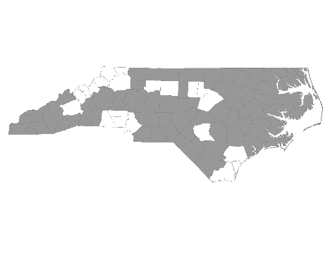


Davie-Iredell-Stokes-Surry-Yadkin (DISSY) Regional Committee
Meeting Minutes
Tuesday May 8, 2018 - 10:00 am
Location: Partners BHC, 200 Elkin Business Park Dr. Elkin, N.C. 28621

Those present were:

Kevin Hege - DISSY Regional Committee lead/ Surry Co. Veteran’s Council
Brian Smith - SHAHC
Cynthia Cothren - The Ark
Debbie Owen - Fifth Street Ministries, DISSY Rapid Rehousing Coordinator
Bonnie Harper - GHCCM
Alyson Snow - Goodwill
Elisha Harris - YVEDDI
Diane Dunn - Salvation Army GSO
Maxine Manley - Salvation Army SSVF
Gabriel Smith - Salvation Army
Debbie Hunter - Workfirst Surry
Sandra Johnson - Adult Services Surry
Teena Willis - Partners BH (On conference)
Julie Pohlman - Community Care (On conference)

Kevin called the meeting to order and welcomed everyone.

He made a motion to accept the minutes from April 10, 2018. Cynthia Cothren seconded the motion and it was approved.

We then received updates from the following agencies that provide services to the homeless within the five county region:

- Diakonos, Inc. dba Fifth Street Ministries - Fifth Street served 111 single individuals and 7 families. They are still accepting referrals. My Sister’s House, battered women’s shelter, served 22 women and 20 children. The Veteran’s Transitional Housing Program served 5 veterans in the house, and at Fifth Street. All services offered by Fifth Street Ministries are available to anyone within the five county region.
HOME of Mooresville currently has two families. They serve single women and children from Mooresville. They an opening for one family.

- DISSY Rapid Rehousing -There are currently 5 families in housing. Referrals are currently being accepted. Please send in the VISPDAT before filling out the full application. Going forward, Rapid Re-Housing will be open to individuals on a case by case basis.

- SHAHC - Currently has a two bedroom unit available. They offer permanent supportive and transitional housing. Their Transitional program is for families up to 2 years. The family is charged 30% of their income while in the program.

- The Ark - Currently 6 children and 13 adults. They have single slot openings. (top bunk) They serve families and single women who are not victims of domestic violence.

- GHCCM - Currently serving 35 clients. 2 clients recently moved into Section 8 housing.

- Goodwill - Served 541 clients with 85 placed. They have Onin Staffing 10-1 on Thursday, May 10, and also a nutrition workshop from 3:30-4:30. May 11, they are hosting a home buying workshop from 2-3. There will also be an employability workshop which starts on May 15.

- Workfirst Surry Co. - Starting to pick up more clients. Continuing to serve those who qualify for ABAWD. They provide employment services to families with at least one child under age 18. Services include job search, transportation, childcare, and other referrals as needed.

- Surry Co. DSS - Still giving referrals/ doing intakes weekly. Still needs resources for housing, including deposits. Currently using SHAHC as one resource.

- Salvation Army/SSVF - Has preventive and Rapid Re-Housing funds and current openings. Continuing to provide outreach services to Vets.

- Community Care - Provides case management to Medicaid clients with at least one child and singles with a disability through the client’s primary care doctor.

- YVEDDI - Addresses barriers to obtaining increased income by providing assistance/ referrals for childcare, education, transportation, etc.

- Kevin reported the Veterans fundraiser was a success and raised $2000.00. Working on possibility of purchasing (NC Housing) the Grace Clinic for a men’s shelter. There will be a community meeting May 31st.
.

The next meeting will be Tuesday, June12, 2018 at 10:00 A.M. at Partners BHC,
Elkin, NC 28621.

With no further business, the meeting was adjourned.

Respectfully submitted, Deborah W. Owen

