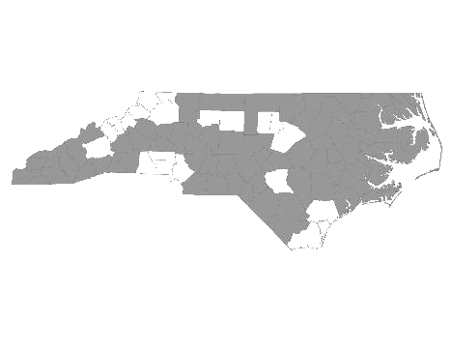


Davie-Iredell-Stokes-Surry-Yadkin (DISSY) Regional Committee
Meeting Minutes
Tuesday April 10, 2018 – 10:00 am
Location: Partners BHC, 200 Elkin Business Park Dr. Elkin, N.C. 28621

Those present were:

Kevin Hege - DISSY Regional Committee lead/ Surry Co. Veteran’s Council
Brian Smith - SHAHC
Christy Champion-Fritz - The Ark
Debbie Owen - Fifth Street Ministries, DISSY Rapid Rehousing Coordinator
Janet Carlton - Goodwill
Sandra Johnson - Surry DSS
Diane Dunn - Salvation Army GSO
Maxine Manley - Salvation Army SSVF
Christien Armour - Goodwill NWNC SSVF
Gabriel Smith – Salvation Army
Mary Williams - Workfirst Surry Co.
Mollie Thompkins - Partners BH
Bonnie Harper - GHCCM (On conference)
Teena Willis - Partners BH (On conference)

Kevin called the meeting to order and welcomed everyone.

He made a motion to accept the minutes from March 20, 2018. Debbie Owen seconded the motion and it was approved.

We then received updates from the following agencies that provide services to the homeless within the five county region:

- Diakonos, Inc. dba Fifth Street Ministries - Fifth Street served120 single individuals and 7 families. They are still accepting referrals. My Sister’s House, battered women’s shelter, served 12 women and 12 children. The Veteran’s Transitional Housing Program served 5 veterans in the house, and 4 at Fifth Street. All services offered by Fifth Street Ministries are available to anyone within the five county region.
HOME of Mooresville currently has two families. They serve single women and children from Mooresville. They an opening for one family.

- DISSY Rapid Rehousing -There are currently 4 families in housing. Referrals are currently being accepted. Please send in the VISPDAT before filling out the full application. Going forward, Rapid Re-Housing will be open to individuals on a case by case basis.

- SHAHC - Currently has candidates for the one and two bedroom units. They offer permanent supportive and transitional housing. Their Transitional program is for families up to 2 years. The family is charged 30% of their income while in the program.

- The Ark - Currently has openings for 2 families and 5 single slots. They serve families and single women who are not victims of domestic violence.

- Goodwill - Goodwill has job fairs Tuesday (2-4) and Wednesday 10:00 this week. They have employers currently looking for workers to fill open positions. They are sponsoring mammogram screenings from 9-4 on June 19th at Goodwill. Susan B. Komen cancer awareness is June 15th 3:30-4:30.

- Workfirst Surry Co. - Currently looking for agencies who will agree to provide onsite work experience/ internships for those clients in Workfirst. Looking for more clients from areas of Surry Co. other than Mt. Airy/ Mt. Pilot area. They provide employment services to families with at least one child under age 18. Services include job search, transportation, childcare, and other referrals as needed.

- Surry Co. DSS - Needs resources for housing, including deposits. Currently using SHAHC as one resource.

- Salvation Army/SSVF - Has preventive funds and current openings. Share the warmth program will change from heat to air conditioning assistance in the near future. Also provides outreach to Vets who may have income, but do not want housing.

- Partners BH - Peer Support Training is available. See the Partners website for a list of training dates and times. There is a Stand-down for Veterans at CVCC April 13th. Numerous resources and vendors will be available. There is a need for a Scorecard Committee Representative in case anyone is interested.
There are still targeted units available. Must have clean background and permanent income.

- Kevin reminded everyone of the Coordinated Assessment conference call on April 25 from 10-12.
Also, there is a storage unit paid for by the VFW which has clothes, sleeping bags tents, food etc. This is available to anyone needing assistance, not just Veterans.

The next meeting will be Tuesday, May 8, 2018 at 10:00 A.M. at Partners BHC,
Elkin, NC 28621.

With no further business, the meeting was adjourned.

Respectfully submitted, Deborah W. Owen

Coordinated Assessment Sub Committee
The committee met. The process will be changing shortly and will involve HMIS.

