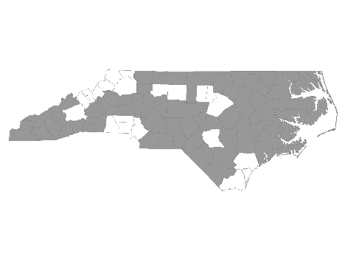


Davie-Iredell-Stokes-Surry-Yadkin (DISSY) Regional Committee
Meeting Minutes
Tuesday February 13, 2018 – 10:00 am
Location: Partners BHC, 200 Elkin Business Park Dr. Elkin, N.C. 28621

Those present were:

Brian Smith - SHAHC
Debbie Owen - Fifth Street Ministries, DISSY Rapid Rehousing Coordinator
Michele Knapp - Fifth Street Ministries
Mary Boyles - Shepherd’s House (on conference)
Bonnie Harper - GHCCM (on conference)
Alisha Pruett - Community Link (on conference)
Alyson Snow - Goodwill CC Elkin
Christien Armour - Goodwill NWNC SSVF
Diane Dunn - Salvation Army GSO
Gabriel Smith - Salvation Army WS
Maxine Manley - Salvation Army SSVF
Mary Williams - Workfirst Surry Co.
Rahim Skinner - Cardinal Innovations
Sandra Johnson - DSS Adult Services Surry Co.
Teena Willis - Partners BH

Teena called the meeting to order and welcomed everyone.

She made a motion to accept the minutes from January 9, 2018. The motion was then approved by common consent.

We then received updates from the following agencies that provide services to the homeless within the five county region:

- Diakonos, Inc. dba Fifth Street Ministries -The shelter served 112 single women and men, and 6 families (9 children, 8 adults) this period. They are still accepting referrals. My Sisters House, battered women’s shelter, housed 14 women and 19 children. The Veteran’s Transitional Housing Program served 3 veterans in the house and 6 at Fifth Street. Openings are currently available at the Veteran’s House. All services offered by Fifth Street Ministries are available to anyone within the five county region.
The new shelter, HOME of Mooresville, opened the end of December. They serve single women and children from Mooresville. They are currently full with 3 families.

- DISSY Rapid Rehousing -There are currently 5 families in housing. Referrals are currently being accepted. Please send in the VISPDAT before filling out the full application. Going forward, Rapid Re-Housing will be open to individuals on a case by case basis.

- SHAHC - Two individuals were placed in housing this period. There is still a two bedroom available. Their Transitional program is for families up to 2 years. The family is charged 30% of their income while in the program. They also offer permanent supportive housing.

- Shepherd’s House - Nothing to report.

- Community Link - Has full funding and is currently taking referrals.

- Goodwill CC Elkin - Served 253 clients to date with 146 placements. For Veterans who are enrolled in their program, there are funds available for rent, deposits, and utilities.

- GHCCM - Has openings for permanent supportive housing in Iredell Co. Currently serving over 30 clients.

- Cardinal Innovations - Reported that during the PIT count, a homeless camp in Stokes Co. was located. Going forward, Karisa McDaniels will be assisting with their HUD program.

- Workfirst Surry Co. - Currently providing services to more non-parental clients. Trying to gain more exposure in the community by providing services at Goodwill centers etc. Provides employment services to families with at least one child under age 18. Services include job search, transportation, childcare, and other referrals as needed.

- Salvation Army GSO - Has Share the Warmth Program. Assisting Vets with utilities. They are able to assist 5 Vets on Tuesday and Thursdays.

- Goodwill NWNC – Referring to other resources.

- Surry Co. Adult Services - Provides assistance and referrals to those needing help with housing, utilities, budgeting, etc. Weekly intakes available.

- Partners BH - Mental Health First Aid training is available free of charge. (Need 10 people in order to have training.) Looking for an agency to take over and implement the Shelter Plus grant.

Reminders:

PIT count information due to Brian (SHAHC) by February 15th.
Coordinated Assessment conference calls the 2nd Friday of the month @11:00.

The next meeting will be Tuesday, March 9, 2018 at 10:00 A.M. at Partners BHC,
Elkin, NC 28621.

With no further business, the meeting was adjourned.

Respectfully submitted, Deborah W. Owen

Coordinated Assessment Sub Committee
The committee did not meet.

