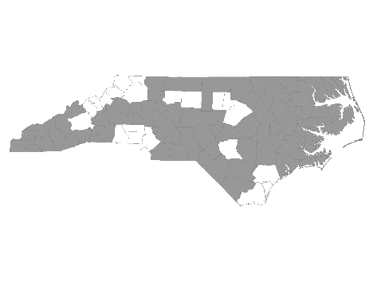


Davie-Iredell-Stokes-Surry-Yadkin (DISSY) Regional Committee
Meeting Minutes
Tuesday January 9, 2018 – 10:00 am
Location: Partners BHC, 200 Elkin Business Park Dr. Elkin, N.C. 28621

Those present were:

Kevin Hege - NC Dept of Commerce (Surry, Yadkin)
Christy Fritz - The Ark
Mary Boyles - Shepherd’s House (on conference)
Brian Smith - SHAHC (on conference)
Debbie Owen - Fifth Street Ministries, DISSY Rapid Rehousing Coordinator
Michele Knapp -Fifth Street Ministries
Krystal Dumas - Just Hope (on conference)
Janee Parker - Family Endeavors (on conference)
Bonnie Harper - GHCCM (on conference)
Christien Armour - Goodwill NWNC SSVF
Diane Dunn - Salvation Army GSO
Maxine Manley -Salvation Army SSVF
Rose Fisher - United Way SSVF (on conference)
Alyson Snow - Goodwill CC Elkin
Debbie Hunter - Workfirst Surry Co.
Kanci McKnight - Children’s Center Surry
Rahim Skinner - Cardinal Innovations

Kevin Hege called the meeting to order and welcomed everyone.

He made a motion to accept the minutes from December 12, 2017. Michele Knapp seconded the motion and it was approved.

We then received updates from the following agencies that provide services to the homeless within the five county region:

- Diakonos, Inc. dba Fifth Street Ministries -The shelter served 96 single women and men, and 8 families (12 children, 9 adults) this period. They are still accepting referrals. My Sisters House, battered women’s shelter, housed 14 women and 15 children. The Veteran’s Transitional Housing Program served 3 veterans in the house and 6 at Fifth Street. Openings are currently available at the Veteran’s House. All services offered by Fifth Street Ministries are available to anyone within the five county region.
The new shelter, HOME of Mooresville, opened the end of December. They serve single women and children from Mooresville. They currently have one family.

- DISSY Rapid Rehousing -There are currently 7 families in housing, 4 from Iredell and 3 from Surry. Please send in the VISPDAT before filling out the full application. Going forward, Rapid Re-Housing will be open to individuals on a case by case basis.

- The Shepherds House - Currently has openings for 4 singles or a family.

- SHAHC - There is still a one bedroom and two bedroom available. Their Transitional program is for families up to 2 years. The family is charged 30% of their income while in the program. They also offer permanent supportive housing.

- The Ark - Currently serving 17 clients with openings for two singles. They serve families and single women who are not victims of domestic violence.

- United Way SSVF - Needs MOU for Coordinated Assessment. Has current openings for Rapid Re-Housing and prevention.

- Goodwill CC Elkin – Served 102 clients to date with 8 placements.

- Just Hope - Currently out of funding for housing. Giving referrals to Family Promise. In the process of preparing for the PIT count.

- GHCCM - Needs MOU for Coordinated Assessment. Has openings for permanent supportive housing in Iredell and Surry.

- Cardinal Innovations - Will be assisting with PIT count through Stokes Homeless Outreach.

- Goodwill NWNC SSVF - Accepting referrals. Has funding including prevention.

- Workfirst Surry Co. - Provides employment services to families with at least one child under age 18. Services include job search, transportation, childcare, and other referrals as needed.
Currently providing employment and housing services, as well as assisting those who qualify for ABAWD.

- Surry County Veterans Counsel - Assisted 15 Veterans with job search activities.

Kevin reviewed PIT count information including who will cover which counties, what information should be collected, and what criteria must be met for sheltered and unsheltered. The PIT count is scheduled for January 31.

The next meeting will be Tuesday, February 13, 2018 at 10:00 A.M. at Partners BHC,
Elkin, NC 28621.

With no further business, the meeting was adjourned.

Respectfully submitted, Deborah W. Owen

Coordinated Assessment Sub Committee
The subcommittee did not meet.

