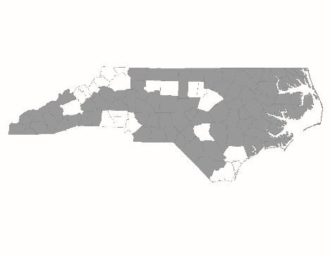

NC Balance of State CoC
Regional Committee 2019 PIT/HIC Planning Worksheet

2019 PIT/HIC Goal:
The NC Balance of State CoC will produce an accurate and comprehensive count of all literally homeless individuals and families in the 79-county geographic region.

Instructions:
- Convene a PIT/HIC Planning Committee representative of the full Regional Committee and the different populations experiencing homelessness in the region to complete this worksheet.
- Complete every question in the planning worksheet or mark N/A when the question is not applicable.
- The worksheet contains five sections. These sections represent the areas in which Regional Committees need to develop plans to ensure that it can produce an accurate and comprehensive PIT/HIC count:
  - Planning Committee information;
  - Advertisement;
  - Volunteers;
  - Sheltered Count; and
  - Unsheltered Count.

Section 1: Regional Committee Information
PIT Lead:

PIT Lead email and phone:
Email:
Phone:
PIT/HIC Planning Committee Members:
Name: Email:
Name: Email:
Name: Email:
Name: Email:
Name: Email:
Name: Email:
Name: Email:
Name: Email:
Name: Email:
Name: Email:

NOTE: Planning Committees should attempt to have a breadth of voices at the table, representing each of the counties in the Regional Committee, different program types, and special populations such as unsheltered individuals, youth, Veterans, and domestic violence survivors.

Section 2: Advertisement
- Please explain how the PIT/HIC Planning Committee will inform the full Regional Committee about the plan for this year’s count and elicit feedback and ideas from stakeholders.

- Please explain how the PIT/HIC Planning Committee will advertise this year’s count to the larger community. Include important partners who may not usually be at Regional Committee meetings that need special outreach to be included.

- Please explain how the PIT/HIC Planning Committee will advertise this year’s count to people experiencing homelessness. Include where and when this advertisement will occur in the community. Explicitly address how this advertisement will reach these hard-to-reach populations: unsheltered individuals, youth, Veterans, and disabled people.

Section 3: Volunteers
- Approximately how many volunteers will you need for each of the PIT count activities listed below:
Activity | Number of Volunteers Needed
Street Count: County 1 – List County Here:
Street Count: County 2 – List County Here:
Street Count: County 3 – List County Here:
Street Count: County 4 – List County Here:
Street Count: County 5 – List County Here:
Street Count: County 6 – List County Here:
Street Count: County 7 – List County Here:
Street Count: County 8 – List County Here:
Street Count: County 9 – List County Here:
Street Count: County 10 – List County Here:
Service-based Counts
Sheltered Counts

- Explain how the PIT/HIC Planning Committee advertises the need for volunteers. Include which groups that the PIT/HIC Planning Committee will outreach to ask for volunteer assistance.

Section 4: Sheltered Count
- Identify the shelter and transitional housing programs that exist across the Regional Committee’s geographic area. Only programs dedicated to people experiencing homelessness should be included in the region’s PIT/HIC count each year. PIT Leads should ask all agencies if homelessness is an eligibility requirement of the program. If so, include the program in the table below.
Organization / Program Name | Program Type | Contact Name | Email | Phone | County

- Explain how the Regional Committee will train staff at shelter and transitional housing programs to ensure that they understand appropriate definitions, how to fill out required forms or produce appropriate HMIS reports, and how to count accurately per this year’s PIT/HIC regulations. When does the Regional Committee plan to provide this training?
Section 5: Unsheltered Count
- Name an unsheltered PIT Count Facilitator for each county to implement and oversee local activities. Some Regional Committees may choose to have the same person be the lead for all counties or for multiple counties.
County | County PIT Facilitator | Email Address
County 1:
County 2:
County 3:
County 4:
County 5:
County 6:
County 7:
County 8:
County 9:
County 10:

- Will the Regional Committee conduct a service-based unsheltered count (Yes or No)?
  - If yes, please list the programs or facilities where the service-based count(s) will occur. Mark as N/A if the Regional Committee is not conducting a service-based unsheltered count.
Location of service-based count | County | Date of service-based count

- Will the Regional Committee conduct a street-based unsheltered count (Yes or No)?

  - If yes, please describe the process planned for the street-based counts. Include the counties in which the Regional Committee will conduct street-based counts, the time these counts will occur, and the measures the Regional Committee will take to ensure the safety of enumerators. Mark as N/A if the Regional Committee is not conducting a street-based count.

- Regional Committees are required to conduct an accurate and comprehensive unsheltered count across its entire geographic region in all counties. How will the mix of service-based and street-based unsheltered counts allow the Regional Committee to produce an accurate and comprehensive count of unsheltered individuals?

- Explain how the Regional Committee will train volunteers conducting service-based and street-based unsheltered counts to ensure that they understand appropriate definitions, how to fill out required forms, and how to count accurately per this year’s PIT/HIC regulations. When does the Regional Committee plan to provide this training?

- If the Regional Committee is not conducting both service-based AND street-based counts, describe how the chosen method will allow the Regional Committee to count all unsheltered individuals in the geographic region.

