Child Bedroom Kit Order Form
Complete 1 Per Bedroom
Head of Household Name: ______
Number of Children in Bedroom: ______
Bedframe
Household does not need
Quantity: ______
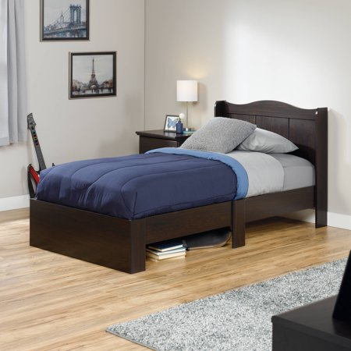  Dark Brown | 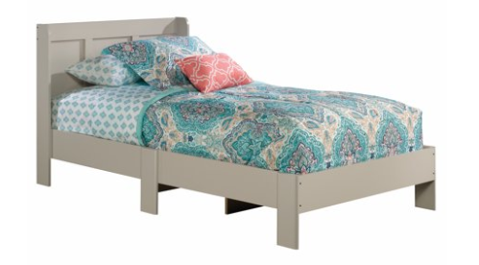  Light Gray
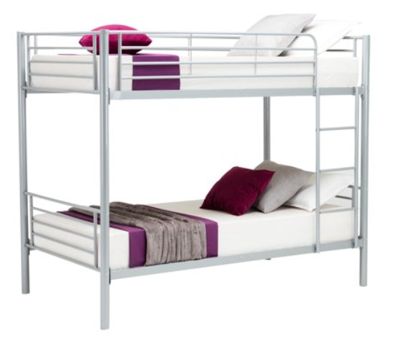

Silver Metal
(only for child bedrooms with 2 or more children)

Twin Mattress
Mattress Needed? Yes No
Quantity: ______
Crib (comes with crib, mattress, sheets)
Crib needed? Yes No
Quantity: ______

Lamp
Household does not need
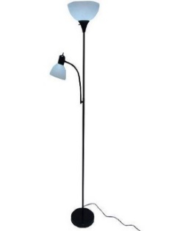  Black and White | 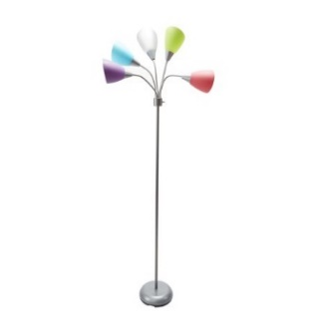  Multi-Colored

Dressers
Household does not need
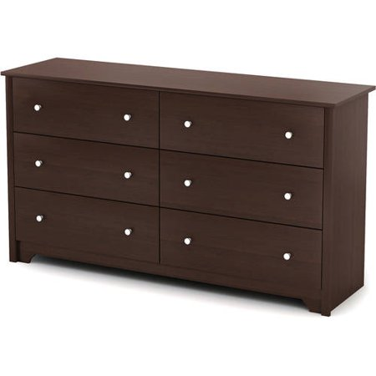  Brown | 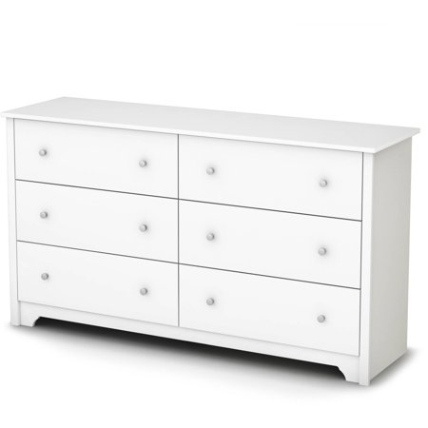  White

Twin Bedding Sets (Includes Sheets, comforter, Pillow Cases, 2 Pillows)
Household does not need
If more than one child in room, indicate quantity of each bedding set desired under checkbox.
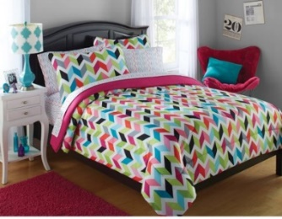  Pink, Blue, Green, Dark Blue | 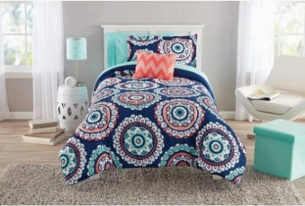  Aqua, Peach, Dark Blue
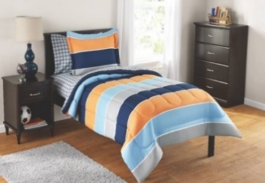  Dark Blue, Light Blue, Orange | 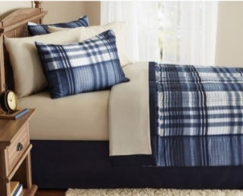  Blue Plaid
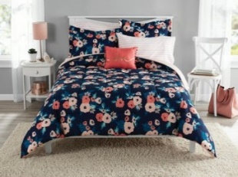  Pink Flowers on Dark Blue | 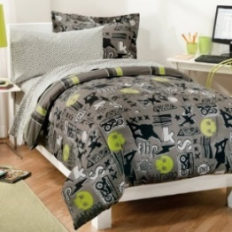  Black, Gray, and Green  (Cats and Skulls Pattern)

Curtain Rods
Unit has blinds (units with blinds are not eligible curtains)
Household does not need
Quantity: ______
Number of windows larger than 4 feet wide (including frame):
Number of windows less than 4 feet wide (including frame):

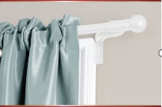  White | 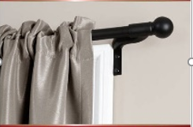  Black

Curtains
Unit has blinds (units with blinds are not eligible curtains)
Household does not need
Quantity: ______
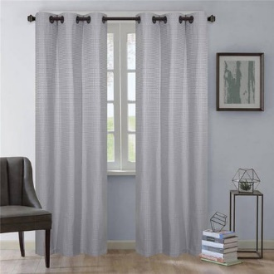  Gray | 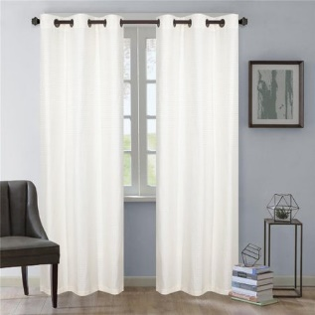  White
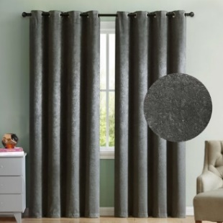  Dark Gray | 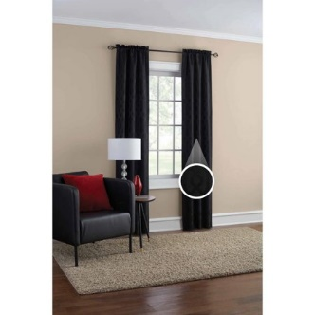  Black

