Adult Bedroom Kit Order Form
Complete 1 per Bedroom
Head of Household Name: _______________________________________________________
Number of Adults in Bedroom: _____
Queen Platform Bedframe
Household does not need
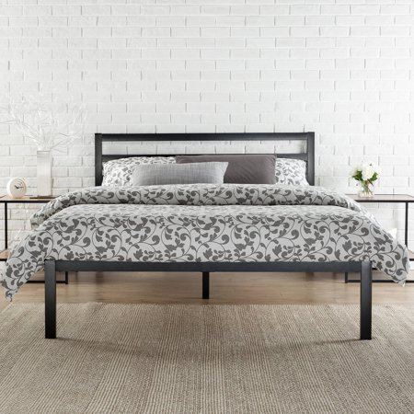  Black | 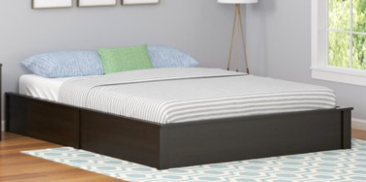  Dark Brown

Queen Mattress
Mattress Needed? Yes No

Dresser
Household does not need
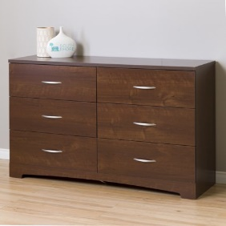  Brown | 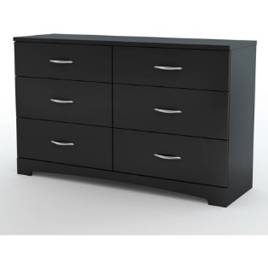  Black

Queen Bedding Sets (Includes Sheets, Comforter, Pillow Cases, 2 Pillows)
Household does not need
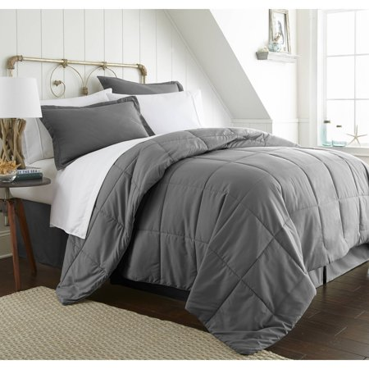  Gray | 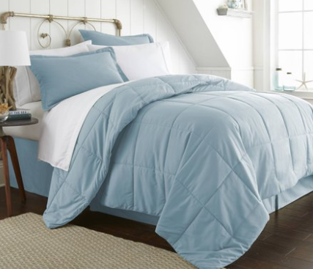  Light Blue
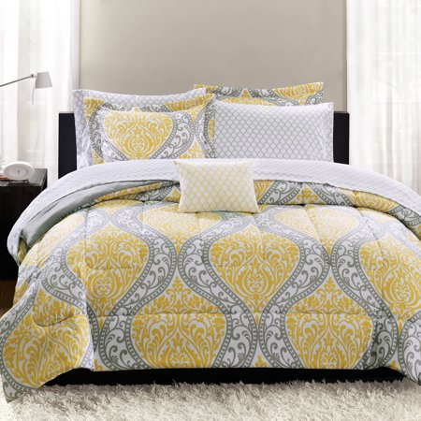  Yellow and Gray | 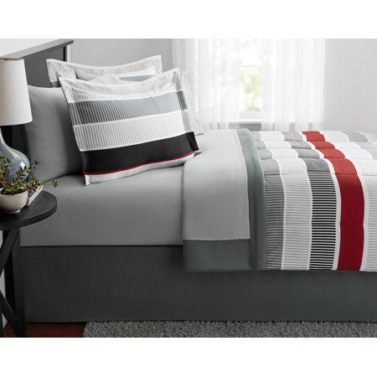  Gray, Black, and Red

Lamp with Nightstand
Household does not need
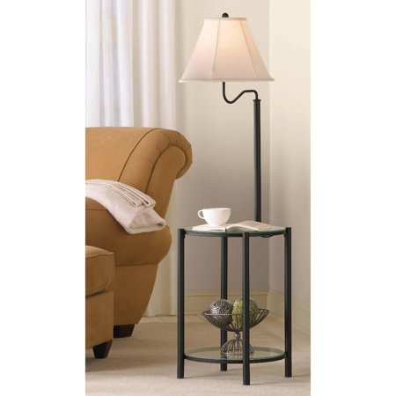  Black with White Shade | 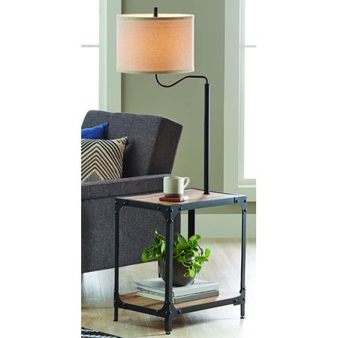  Black with Cream Shade

Curtain Rods
Unit has blinds (units with blinds are not eligible curtains)
Household does not need
Quantity: _____
Number of windows larger than 4 feet wide (including frame):
Number of windows less than 4 feet wide (including frame):
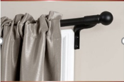  Black | 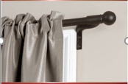  Brown

Curtains
Unit has blinds (units with blinds are not eligible curtains)
Household does not need
Quantity: _____
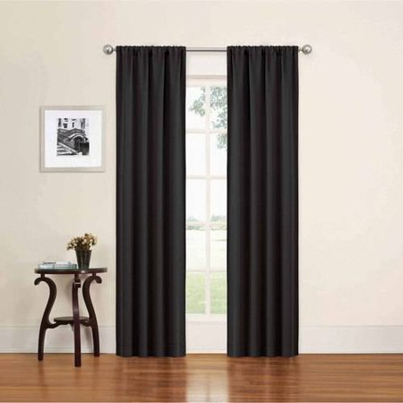  Black | 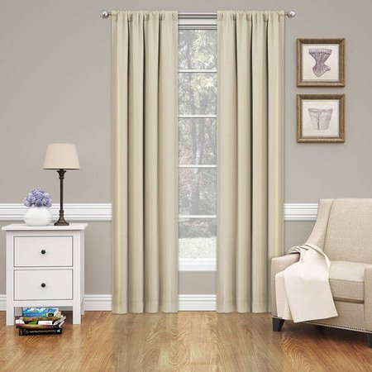  Off White
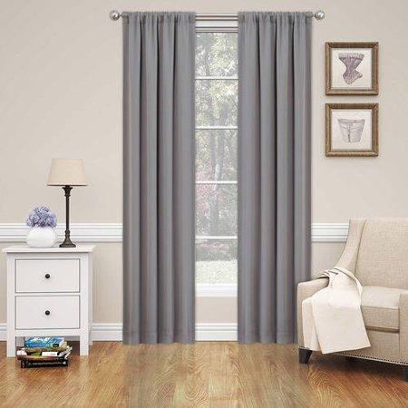

Gray

