Move-In Kit Order Form

Household Information
Head of Household Name:
Address:
Number of Bedrooms:
Number of Bathrooms:
Number of Adults in Household:
Number of Children in Household:
Rehousing Agency:
Does the household need help with moving? | Yes No

Each unit will receive a furniture kit, welcome basket, bathroom kit, and necessary bedroom kits. Each household should complete this form and adult or child bedroom form for each bedroom.
Items listed may be subject to change based on availability. If an item is out of stock, staff will substitute with a similar item.
If a household has already received items from Rehousing Agencies or does not want/need items, they should select “household does not need” option.

Welcome Basket
Please choose items that the household wants in their welcome basket:
Trash Cans (2) and Trash Bags  Toilet Paper  Paper Towels  Broom/dustpan  Mop  Glass Cleaner | Bleach Spray  Sponges  Dish Soap  Lightbulbs  Hangers  Can Opener
Furniture Kit (Choose 1 of Each)
Sofa
Household does not need
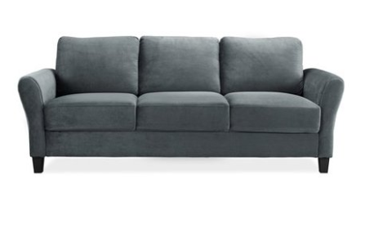  Gray | 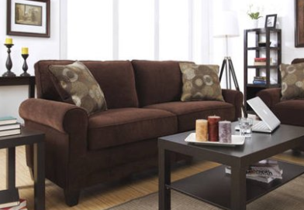  Brown

Coffee Table
Household does not need
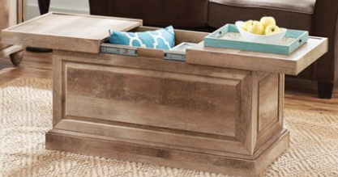  Light Brown Wood | 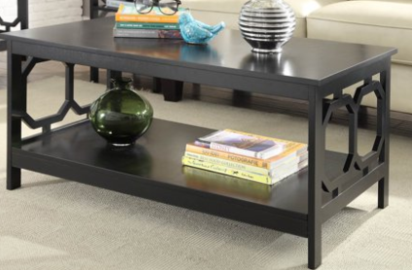  Black

Curtains
Unit has blinds (units with blinds are not eligible curtains)
Quantity:
Household does not need
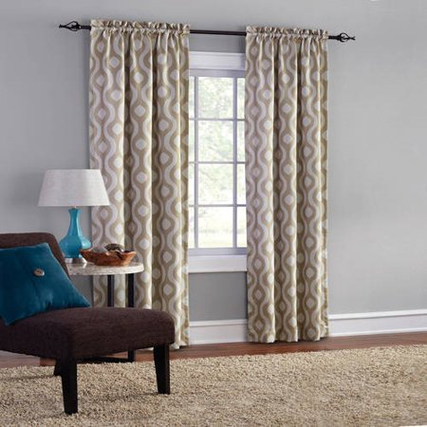  Taupe | 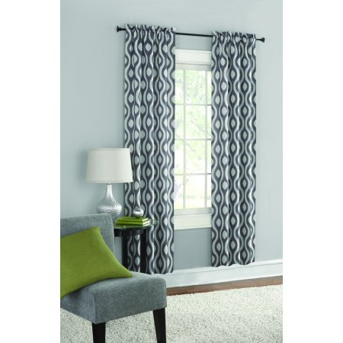  Black

Curtain Rod
Unit has blinds (units with blinds are not eligible curtains)
Household does not need
Quantity: ______
Number of windows larger than 4 feet wide (including frame):
Number of windows less than 4 feet wide (including frame):
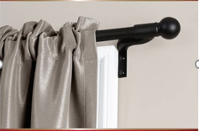  Black | 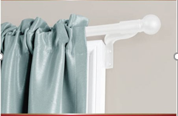  White

Kitchen Table (For family of 4 or less)
Household does not need
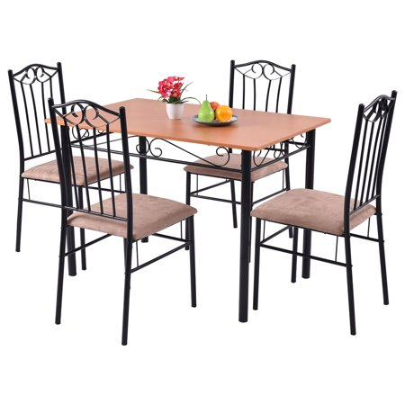  Black and Light Wood | 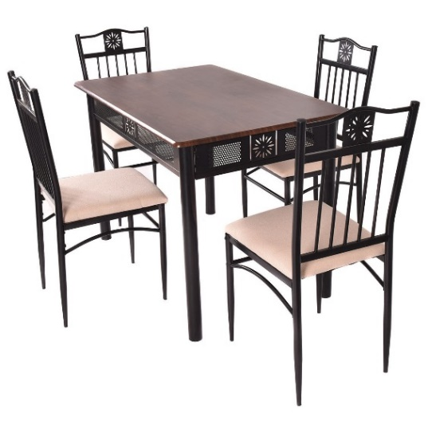  Black and Dark Wood

Kitchen Table (For family of 5 or more)
Household does not need
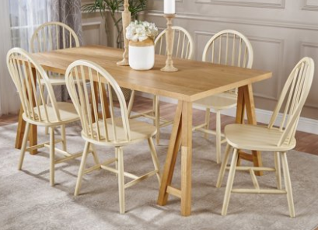  White and Light Wood | 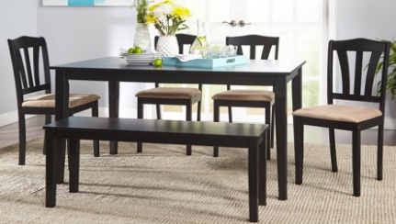  Black

TV
Household does not need
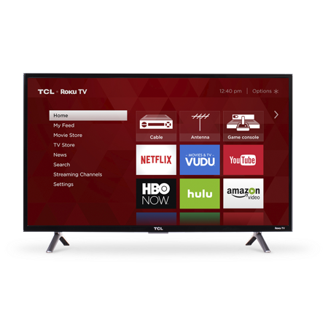

Lamps
Household does not need
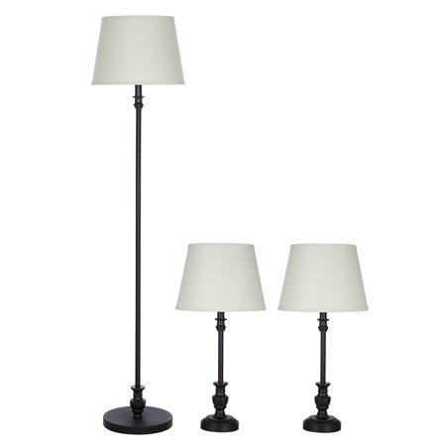  Bronze with White Shades | 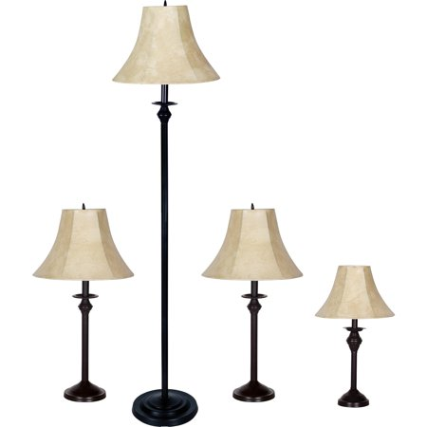  Bronze with Off White Shades | 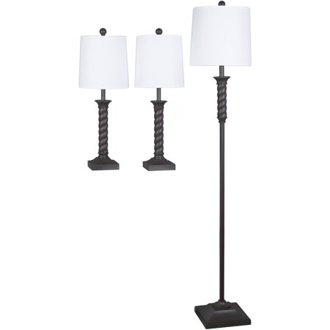  Brown with White Shades

TV stand
Household does not need
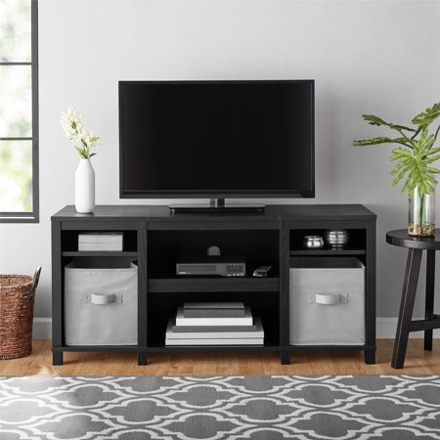  Black | 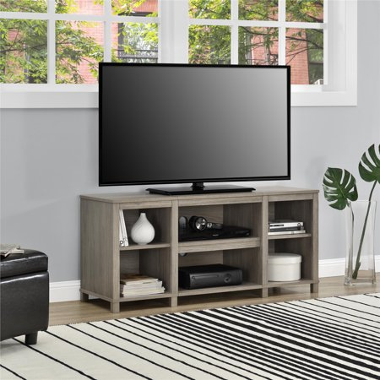  Gray Wood

Kitchen Kit (Choose 1 of Each)
Plates
Household does not need
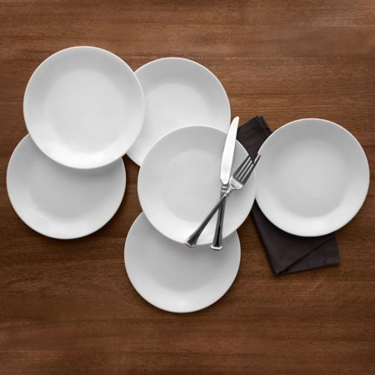  White | 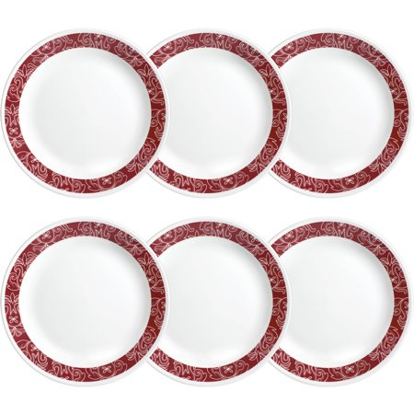  White with Red Pattern Border

Bowls
Household does not need
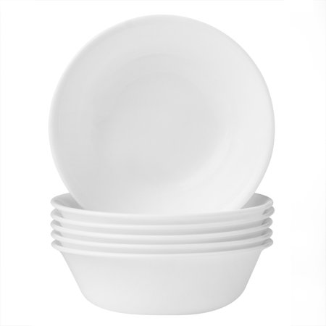  White | 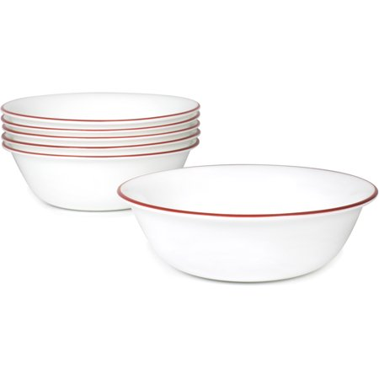  White with Red Border

Silverware
Household does not need
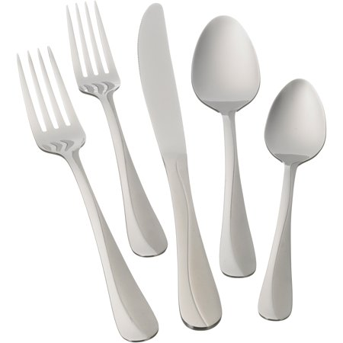 | 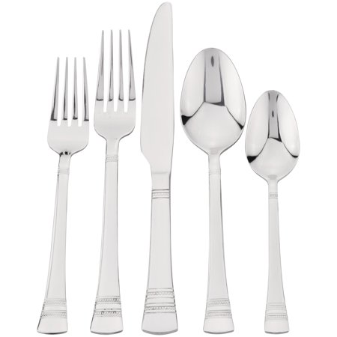

Glasses
Household does not need
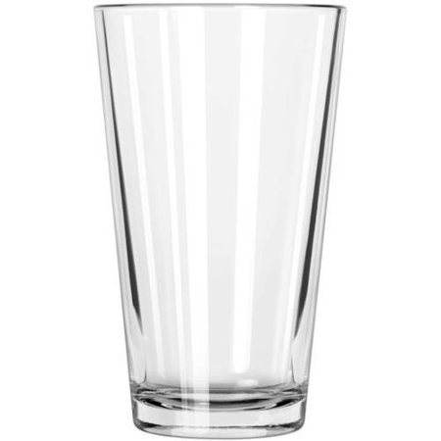 | 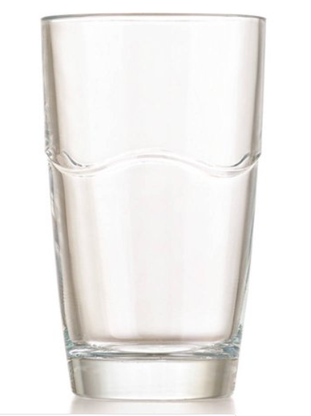

Mugs
Household does not need
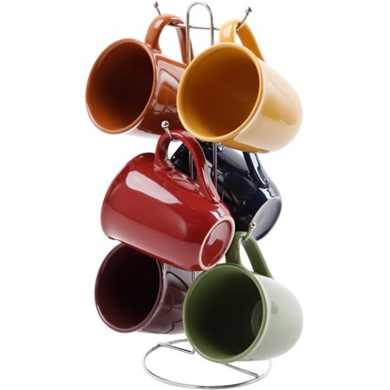  Multi-Colored Set | White

Microwave
Microwave needed? Yes No
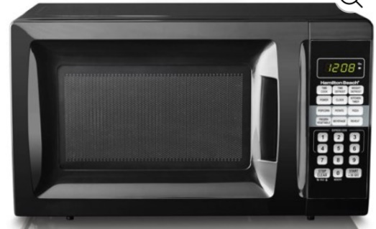

Cookware Sets
Household does not need
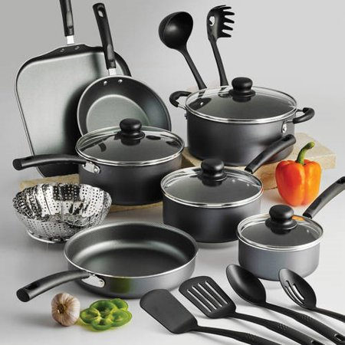  Black | 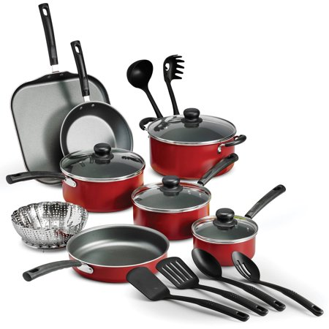  Red

Knife Sets
Household does not need
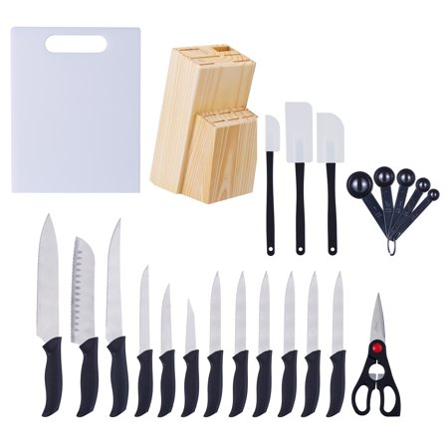 | 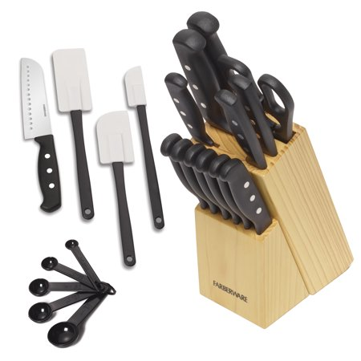  Comes with Cutting Board with Red Border

Bathroom Kits
Number of Bathrooms in the Unit:
If more than one bathroom, indicate quantity of each shower curtain, bath rugs, and towels desired under checkbox.
Shower Curtains and Hooks (comes with Shower Liner)
Household does not need
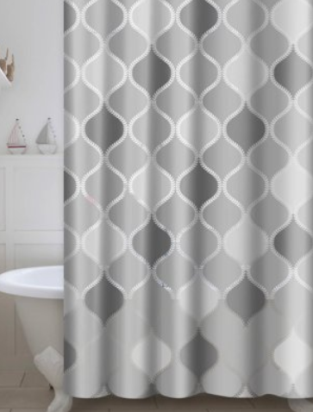  Light Gray and Dark Gray | 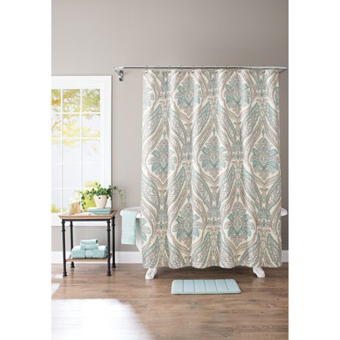  Light Blue and Brown
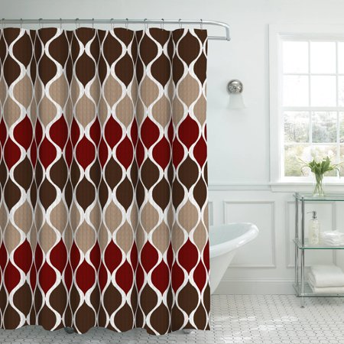

Dark Brown, Light Brown, and Red

Bath Rugs
Household does not need
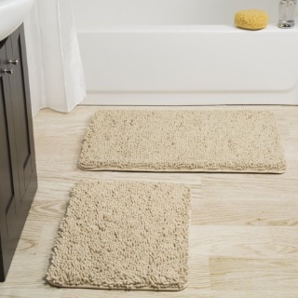  Ivory | 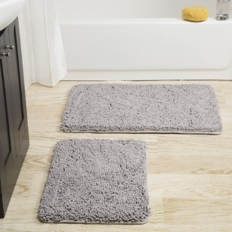  Gray

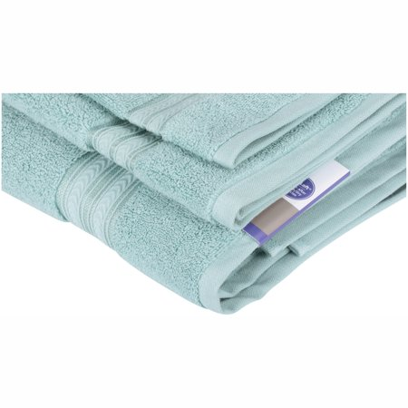  Blue | 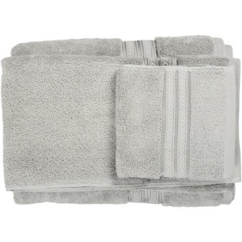  Silver | 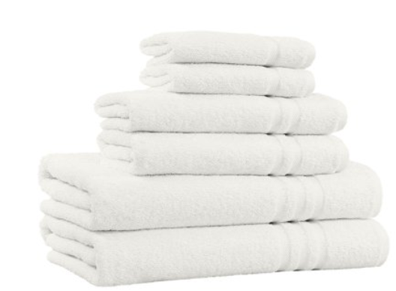  Ivory
Bath Towels
Household does not need

Laundry Detergent
Household does not need
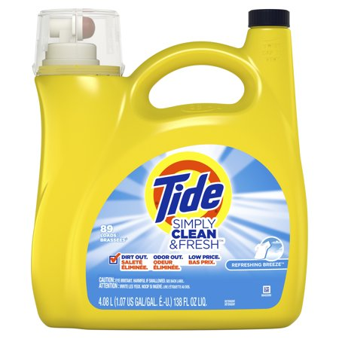 | 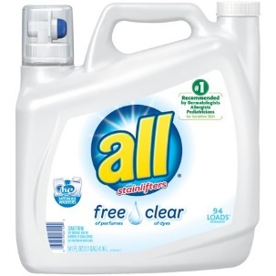

Toothpaste
Household does not need
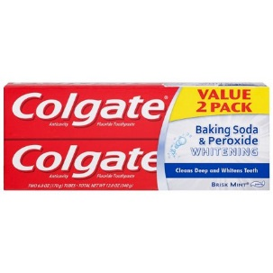 | 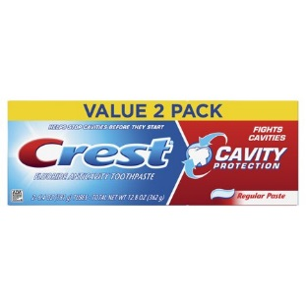

Toothbrushes
Household does not need
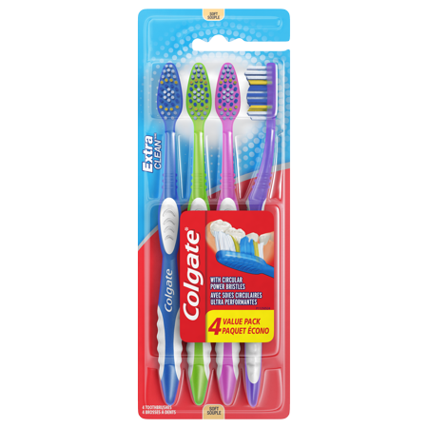

Shampoo/Conditioner
Household does not need
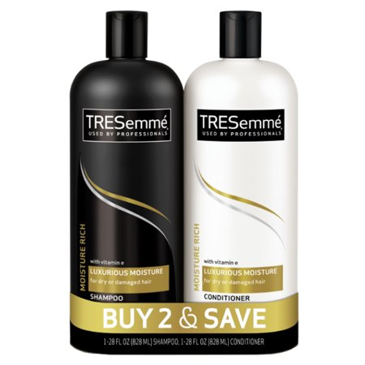 | 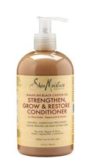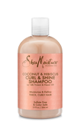
Soap
Household does not need
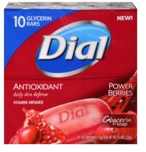 | 