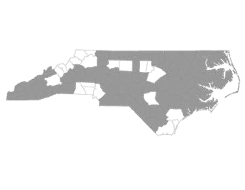Regional Committee Coordinated Assessment Plan

In June 2016 the BoS CoC Steering Committee adopted a Regional Committee Restructuring Proposal, changing the organizational structure of the BoS CoC from 26 Regional Committees to 13 larger Regional Committees. The BoS CoC Steering Committee also adopted written standards for coordinated assessment on September 6, 2016, that outline how coordinated assessment should operate in each region.

Taking into account both the new Regional Committees and written standards, each Regional Committee will be required to submit a coordinated assessment plan that provides coverage for their entire geographic region by April 1, 2017.

Contact Information
Regional Committee:
Counties Served:
For the following please provide name and email address.
Primary Authors of the Plan:
Regional Lead:
Elected Coordinated Assessment Lead:
Other Coordinated Assessment Contact(s) for the Region:

Prevention and Diversion Screen
The prevention and diversion screen is administered when households present in a housing crisis to see if there are any other safe housing options available to them besides a shelter bed. This screen allows communities to prioritize shelter beds for those with no other options. It is recommended that the coordinated assessment system make an initial contact to assess within 2 hours of households presenting for services.

Please use the following chart to list agencies who administer the prevention and diversion screen in your region:

Agency | Count(ies) Served | Population Served | Availability to administer screen | Number Staff Trained  (recommend more than 1 staff) | Active on HMIS
 |  | Families Only  Single Men  Single Women  All | Days:  Times: |  | Yes  No
 |  | Families Only  Single Men  Single Women  All | Days:  Times: |  | Yes  No
 |  | Families Only  Single Men  Single Women  All | Days:  Times: |  | Yes  No
 |  | Families Only  Single Men  Single Women  All | Days:  Times: |  | Yes  No
 |  | Families Only  Single Men  Single Women  All | Days:  Times: |  | Yes  No
 |  | Families Only  Single Men  Single Women  All | Days:  Times: |  | Yes  No
 |  | Families Only  Single Men  Single Women  All | Days:  Times: |  | Yes  No

If your Regional Committee does not have 24-hour availability for the prevention and diversion screen, please describe what happens if a household needs emergency services and shelter outside of the available hours, including what happens if a household presents overnight, on the weekends, or if trained staff is not present. Be sure to address how the household accesses shelter and when the prevention and diversion screen is administered.

Domestic Violence Referrals
While answering questions on the prevention and diversion screen, households may be identified as needing domestic violence services.

If a household indicates they need domestic violence services and/or shelter, please list the agencies your region refers to:

Agency | Count(ies) Served | Participate in Coordinated Assessment
Yes
No
Yes
No
Yes
No
Yes
No
Yes
No

Please describe the process by which agencies making referrals make contact with and transfer forms to the domestic violence agency and how the system tracks if a household was successfully placed in a program. Be sure to include if a phone call is made to the agency to inform them of the referral, and/or if forms are sent with households to the agency.

If domestic violence agencies are not currently participating in your coordinated assessment process, please describe the engagement plan for these agencies, including goals and timeline.

Does your region need assistance in engaging domestic violence agencies? Yes No
If yes, please provide the name, email and phone number of the person to contact:

Diversion
While answering questions on the prevention and diversion screen, households may be identified as needing diversion services to access a safe housing option.

Does your coordinated assessment system offer mediation services for diversion? Yes No
If yes, please describe the mediation services provided:

Are financial assistance resources available for diversion? Yes No
If yes, how much financial assistance and what sources of funding are used for this?

If households are referred to agencies to receive diversion services, please list agencies in your region:
Agency | Count(ies) Served | Participate in Coordinated Assessment | Services Provided
 |  | Yes  No | Mediation  Financial Assistance
 |  | Yes  No | Mediation  Financial Assistance
 |  | Yes  No | Mediation  Financial Assistance
 |  | Yes  No | Mediation  Financial Assistance
 |  | Yes  No | Mediation  Financial Assistance

Please describe the process by which agencies making referrals make contact with and transfer forms to the diversion agency and how the system tracks if a household was successfully placed in a program. Be sure to include if a phone call is made to the agency to inform them of the referral, if forms are sent with households to the agency, and/or if referrals are sent via HMIS.

Referrals to Shelter
While answering questions on the prevention and diversion screen, households may identify a need for an emergency shelter or access to resources for emergency housing, such as motel vouchers.

If households are referred to shelters and emergency services, please list agencies in your region:

Agency | Count(ies) Served | Participate in Coordinated Assessment | Population Served | Admission Requirements and/or Prioritization Policies | Active on HMIS
 |  | Yes  No | Families Only  Single Men  Single Women  All |  | Yes  No
 |  | Yes  No | Families Only  Single Men  Single Women  All |  | Yes  No
 |  | Yes  No | Families Only  Single Men  Single Women  All |  | Yes  No
 |  | Yes  No | Families Only  Single Men  Single Women  All |  | Yes  No
 |  | Yes  No | Families Only  Single Men  Single Women  All |  | Yes  No
 |  | Yes  No | Families Only  Single Men  Single Women  All |  | Yes  No

Please describe the process by which agencies making referrals make contact with and transfer forms to the emergency shelter and how the system tracks if a household was successfully placed in a program. Be sure to include if a phone call is made to the agency to inform them of the referral, if forms are sent with households to the agency, and/or if referrals are sent via HMIS.

If there are no shelters in your region or a particular population does not have access to a shelter, how do households access an emergency bed in your Regional Committee?

If a household does not meet the admission requirements of a shelter and/or the shelter is full, please describe how the household accesses an emergency bed.

VI-SPDAT
The VI-SPDAT screen identifies housing barriers for households and assists to identify and prioritize households for housing programs. It is recommended that communities administer the VI-SPDAT screen between 12 and 15 days from shelter entry in order to allow households the time to try to find housing without a referral to a housing program.
Please use the following chart to list agencies that are administering the VI-SPDAT in your region:

Agency | Count(ies) Served | Population Served | Availability to Administer the VI-SPDAT | Number Staff Trained (recommend more than 1 staff) | Active on HMIS
 |  | Families Only  Single Men  Single Women  All | Days:  Times: |  | Yes  No
 |  | Families Only  Single Men  Single Women  All | Days:  Times: |  | Yes  No
 |  | Families Only  Single Men  Single Women  All | Days:  Times: |  | Yes  No
 |  | Families Only  Single Men  Single Women  All | Days:  Times: |  | Yes  No
 |  | Families Only  Single Men  Single Women  All | Days:  Times: |  | Yes  No
 |  | Families Only  Single Men  Single Women  All | Days:  Times: |  | Yes  No
 |  | Families Only  Single Men  Single Women  All | Days:  Times: |  | Yes  No

If shelters do not administer the VI-SPDAT, please describe how the system identifies who in shelter needs the assessment and follows up with these households to complete the VI-SPDAT.

How long will your community wait to administer the VI-SPDAT?
If not between 12 and 15 days from shelter entry, why?

Please describe how your Regional Committee provides outreach to unsheltered households to complete a VI-SPDAT and provide a housing referral.

If your community does not currently provide outreach to unsheltered households, please describe the Regional Committee’s plan to develop an outreach effort, including goals and timeline.

Are local domestic violence agencies participating in administering the VI-SPDAT and making housing referrals? Yes No
If so, how is the safety and confidentiality of households taken into account?
If not, please provide your plan to engage local domestic violence agencies, including goals and timeline.

Housing Referral and Waitlist
VI-SPDAT scores provide guidance as to which housing program would be best able to meet the needs of households. The goal of coordinated assessment is to provide a clear and transparent referral process for the people being served and for agencies within the region.

Housing Referral
Orgcode Consulting, Inc., which created the VI-SPDAT assessment tool, recommends the following score ranges for housing referrals:
Individual VI-SPDAT Score
0-3 | No Housing Referral/Basic Information Provided
4-7 | Rapid Rehousing
8-17 | Permanent Supportive Housing
Family VI-SPDAT Score
0-3 | No Housing Referral/Basic Information Provided
4-8 | Rapid Rehousing
9-22 | Permanent Supportive Housing

Does your Regional Committee follow these recommendations for scoring? Yes No
If not, please describe the score ranges the region uses for housing referrals and why.

Please list the housing programs that households are referred to once assessed with the VI-SPDAT:
Agency | Count(ies) Served | Type of Housing Programs | Population Served | Active on HMIS
 |  | PSH  RRH  TH  Other: | Families Only  Single Men  Single Women  All | Yes  No
 |  | PSH  RRH  TH  Other: | Families Only  Single Men  Single Women  All | Yes  No
 |  | PSH  RRH  TH  Other: | Families Only  Single Men  Single Women  All | Yes  No
 |  | PSH  RRH  TH  Other: | Families Only  Single Men  Single Women  All | Yes  No
 |  | PSH  RRH  TH  Other: | Families Only  Single Men  Single Women  All | Yes  No
 |  | PSH  RRH  TH  Other: | Families Only  Single Men  Single Women  All | Yes  No
 |  | PSH  RRH  TH  Other: | Families Only  Single Men  Single Women  All | Yes  No
 |  | PSH  RRH  TH  Other: | Families Only  Single Men  Single Women  All | Yes  No

Please describe the process by which agencies making referrals make contact with and transfer forms to the housing program and how the system tracks if a household was successfully placed in a program. Be sure to include if a phone call is made to the agency to inform them of the referral, if forms are sent with households to the agency, and/or if referrals are sent via HMIS.

Waitlist
If more referrals are received than the agencies that provide that service type can serve, community waitlists should be developed. These waitlists should be shared amongst key partners for community accountability and should prioritize households based on need rather than on a first-come-first-served basis. All households who are homeless (both sheltered and unsheltered) and have completed a VI-SPDAT should be on the community waitlist. Households should remain on the waitlist until a housing referral is accepted, the household disappears for a designated period of time, or the household moves to an institutional setting (jail, prison, etc.). Please see the posted example template of a community waitlist here: http://www.ncceh.org/bos/coordinatedassessment/.

Where is your Regional Committee’s waitlist stored?
Who manages the Regional Committee’s waitlist?
Who has access to the Regional Committee’s waitlist?
Please describe how your community will obtain consent from participants to share and store their information for coordinated assessment. Please indicate how participants will be educated about how their information will be used and how a release of information will be obtained and stored. A sample release of information is here http://www.ncceh.org/bos/coordinatedassessment/.

How will the Regional Committee track participants on the waitlist and prioritize them for housing if they refuse to have their personal information shared through the coordinated assessment process?

How will the Regional Committee confidentially and safely track survivors of domestic violence on the waitlist and prioritize them for housing?
Coordinated assessment written standards require that Regional Committees use a case conferencing committee to review the waitlist and oversee the housing referral process. Please describe how your Regional Committee utilizes a case conferencing committee to aid housing placement.

How does the Regional Committee ensure that the most vulnerable households get housing resources first?

Programs should rarely reject referrals. If they do reject a referral, providers are expected to submit a written reason for the denial to the following agency: . Please outline the specific criteria under which a program may reject a referral (refer to the CA Written Standards for more information).

If a household does not accept a referral, or if a provider declines a referral, the provider and the community should work to refer the client to the next appropriate housing provider and/or emergency shelter to ensure that the household has a safe place to sleep that night. The Regional Committee should also maintain the client’s place on the waitlist for housing. How will the Regional Committee work to connect the household with a more suitable program?

For those on the waitlist who remain in a shelter or transitional housing program, how often is follow-up made with the household to ensure that information stays up-to-date?

For those on the waitlist who are unsheltered, it is recommended that follow-up happen at least every 30 days. How often is follow-up made with these households in your region to ensure information stays up-to-date?

What is your policy for taking a household off of the list?
How many attempts do you make to contact?
What are the procedures if a household is unable to be found? Is there are certain amount of time that they must be lost to the system before being taken off the waitlist?

System Management and Oversight

Transportation
Are people required to travel to different locations to access programs and services in your community? Yes No
Are transportation funds/resources provided? Yes No
If yes, please describe resources, to whom they are available, and how and when they are accessed.
What happens if a household is unable to access transportation resources or any other transportation?

Advertisement
Please explain the strategies the Regional Committee uses to educate agencies and other community systems about coordinated assessment. (Please attach any materials the Regional Committee uses in these efforts, like flyers, slides, posters, handouts, etc.)

Please explain the strategies the Regional Committee uses to educate households who are risk of homelessness or experiencing homelessness about coordinated assessment. (Please attach any materials the Regional Committee uses in these efforts, like flyers, slides, posters, handouts, etc.)

Accessibility
How will the Regional Committee ensure that the Coordinated Assessment process is accessible to people with disabilities? Please indicate which communication services will be available, such as Braille, audio, large type, assistive listening devices, and sign language interpreters. Please indicate any other accommodations that will be available to help people with disabilities access the coordinated assessment system.
Is there an access point in your community accessible to people who use wheelchairs or have limited mobility?
If there is not, or if the access point is difficult to get to, please describe how you will provide outreach that is accessible to people with disabilities.

What steps will the Regional Committee take to help people with Limited English Proficiency or difficulty reading access the coordinated assessment system?

Local Oversight
Coordinated assessment provides community-wide accountability for housing anyone who is experiencing homelessness as quickly as possible. It is recommended that each Regional Committee have a coordinated assessment subcommittee to oversee the system, report out to the Regional Committee, address system grievances, educate and outreach non-participating agencies, and collect and submit outcomes to the CoC.

What is your plan for providing coordinated assessment across the entire Regional Committee? This could be either by merging systems into one large system or overseeing several smaller, county-based coordinated assessment systems.

Why is this the best plan to cover the Regional Committee?

If you are maintaining multiple coordinated assessment systems within your Regional Committee, how will these systems interact with each other? Can referrals be made across boundaries?

Please describe how you foresee the Regional Committee’ s coordinated assessment process changing in the future, including timelines and finding grantees who will cover the entire region.
If the Regional Committee includes communities that have been inactive with the BoS CoC, please describe the region’s plan to engage leaders and agencies in these communities in the coordinated assessment process.

Coordinated Assessment Outcomes
How will outcome data be gathered for quarterly reports to the CoC?
Who will be in charge of submitting, correcting, and reviewing outcomes?

How are finalized coordinated assessment outcome reports presented to the community?

Please describe how your Regional Committee will use coordinated assessment outcome data, including identifying gaps, changing processes, setting goals, advocating for resources, funding new ESG and CoC grantees, etc.

Grievances
Agency Grievance Policy
Please complete the following policy with details from your Regional Committee:
If a provider declines a client referral, that provider should work with the community to refer the client to the next appropriate housing provider and/or emergency shelter to ensure that the household has a safe place to sleep that night.

Programs should only reject referrals in rare instances. Providers may decline out of referrals in a without a meeting. However, if a program declines more referrals than this they will need to meet with to discuss the issue(s) that result in referrals being declined.

Providers are expected to submit a written reason for the denial to . Providers may decline out of referrals in a without a meeting. However, if a program declines more referrals than this they will need to meet with to discuss the issue(s) that result in referrals being declined.

For all other grievances, providers must email a detailed grievance to within days of the adverse action/decision. The will schedule a hearing within days of receiving the grievance and render a decision within days following the hearing. If grievances cannot be resolved at the local level, they may be referred to the CAC for review.

Individual Grievance Policy
Please complete the following policy with details from your Regional Committee:

If a household does not agree with a referral or the assessment process, the coordinated assessment site will attempt to make another appropriate referral based on the household’s needs and the housing resources available.

If the household remains unsatisfied, they may file a grievance with , , or , either verbally or in writing, within days of the attempted referral. will respond within days. If the household does not agree with this local decision, an appeal will be submitted to the CAC for review.

Subpopulations
Describe the process by which your Regional Committee addresses the special resources/issues for the following subpopulations.

Chronically Homeless

Unaccompanied Youth (up to age 24)

Veterans: Each Regional Committee should also be developing a Regional Veteran Plan to End Homelessness, also due April 1.

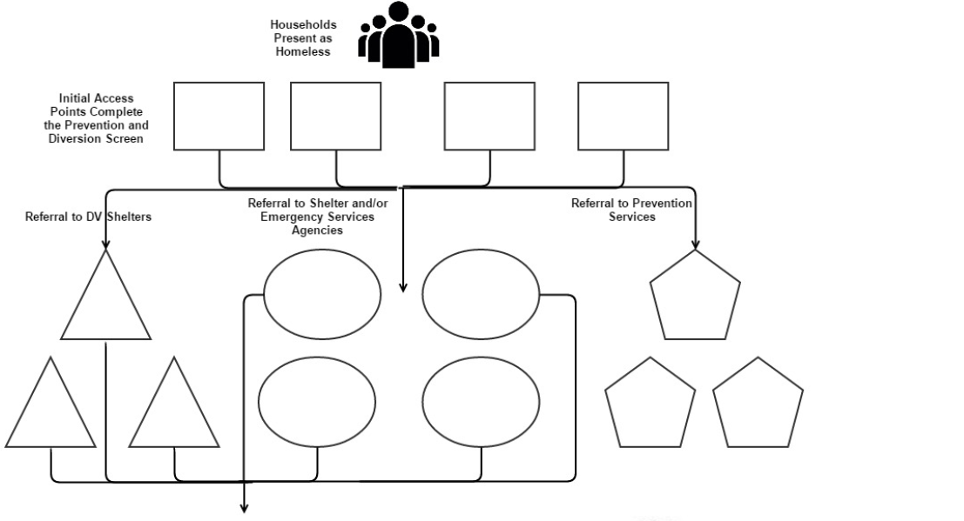
Click here to enter text.

Click here to enter text.

Click here to enter text.

Click here to enter text.

Click here to enter text.

Click here to enter text.

Click here to enter text.

Click here to enter text.

Click here to enter text.

Click here to enter text.

Click here to enter text.

Click here to enter text.

Click here to enter text.

Click here to enter text.

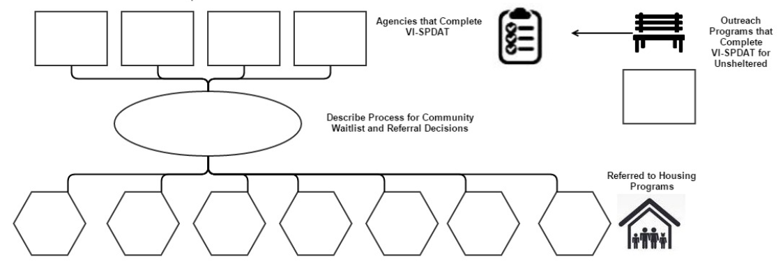
Click here to enter text.

Click here to enter text.

Click here to enter text.

Click here to enter text.

Click here to enter text.

Click here to enter text.

Click here to enter text.

Click here to enter text.

Click here to enter text.

Click here to enter text.

Click here to enter text.

Click here to enter text.

Click here to enter text.

http://www.ncceh.org/bos/restructuring/
http://www.ncceh.org/files/7522/

