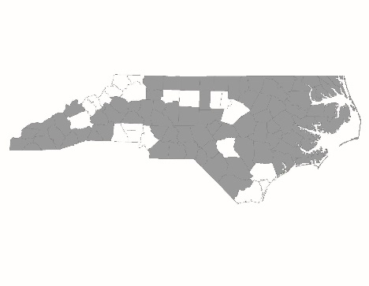

RRH Subcommittee Conference Call
September 16, 2016

Attendees: Jessica Swink, Delores Farmer, Jennifer Molliere, Susan Pridgen, Ginny Rainwater, Teesie Stanton, Amy Steele

Staff: Brian Alexander

Staff reviewed the second core component of the National Alliance on Ending Homelessness Rapid Rehousing Performance Benchmarks and Program Standards.

Rent and Move-In Assistance
This is the second core component of rapid rehousing through which providers pay for short-term or medium-term financial assistance for households experiencing homelessness. This takes the form of payments such as security deposits, utility deposits, ongoing rent and utilities, rent and utility arrears, and move-in assistance.

Two principles
- Rent and move-in assistance needs to be flexible and matched to the needs of the household. It is meant to move these households as quickly as possible into permanent housing.
- Programs maximize the largest number of homeless persons possible, using progressive engagement, providing only the assistance necessary to stabilize people in permanent housing.

Under this core component, the NAEH RRH Performance Benchmarks and Program Standards document lays out a number of standards that all RRH programs should strive for in regards to program staff and program activities.

- Programs want to ensure that staff are trained appropriately to be able to operate the program and be most effective. Programs should train their staff on the regulations governing the RRH funding stream. This means they should know eligibility criteria at intake and through program stay, program requirements, and how much assistance the program will allow. Programs should have a standardized way to train their staff and communicate information as regulations and/or program policies change. We expect that programs will change over time as they learn more about RRH and how it can better help homeless households.
- For program policies:
  - Programs need to have clearly defined policies and procedures defining the amount of financial assistance per household and when assistance should end. It’s important for programs to look and follow the CoC’s written standards. While they do not define the evaluative process for determining how the assistance will be given, they do prescribe the amount of assistance that can be given and the reasons when assistance should or should not end. It will be important for programs to start incorporating these written standards in policies and procedures. The written standards build in the flexibility necessary to meet this standard.
  - Programs need to determine if participants are expected to pay towards their rent. They should have a written policy defining that amount that is reasonable. Programs are not held to the ideal 30% of monthly income amount. This could be 50-60% of income, if appropriate.
  - Programs should use a progressive approach when working with participants. While we standardized the policies and procedures, they should be flexible enough that staff can work to meet a household’s specific needs. Your policies should be very clear as to how the program determines when and if assistance ends. Again, refer back to the written standards to see guidelines in which your program needs to operate.
- For program activities:
  - Programs will provide financial assistance for housing costs that can include rental deposits, rent and utilities, arrears, and move-in costs.
  - Programs need to be timely in their payments and should be able to track these payments to landlords and other vendors.
  - Programs should help households moving into housing procure the basic things to set up a home: furnishings, basic supplies, kitchen items.
  - Programs should focus their attention on helping households transition off of assistance and work with participants to achieve long-term housing stability after assistance ends.

The subcommittee discussed and shared ideas based on this question: What are your thoughts about these RRH program standards? How many of you believe your programs already meet these standards?
- Susan from Onslow County talked about their change from a standard monthly allotment of 6 months to progressive engagement.
- Jennifer from Transylvania County talked about how compliance was easier for them since their program generally only works with people moving into public housing. Transylvania has a good relationship with the PHA and can get folks into public housing in about 4 months. They provide deposits to get into a unit.
  - Questions arose about service eligibility for people moving into public housing. Staff will write an AAQ to determine eligibility and then check with the state ESG office. Staff will follow up with the subcommittee once answers are received.
- Ginny from Piedmont talked about their program which has standard 6 months of financial assistance but is interested in changing to a progressive approach.
  - Questions arose about transferring someone from a RRH program to a PSH program and eligibility. Staff stated that in RRH programs, households maintain their incoming status until exit or termination from the program. This means if they were literally homeless at entry, then they would maintain that status. As long as they were eligible under this status for PSH, then they could move into a PSH program when spots were available.

