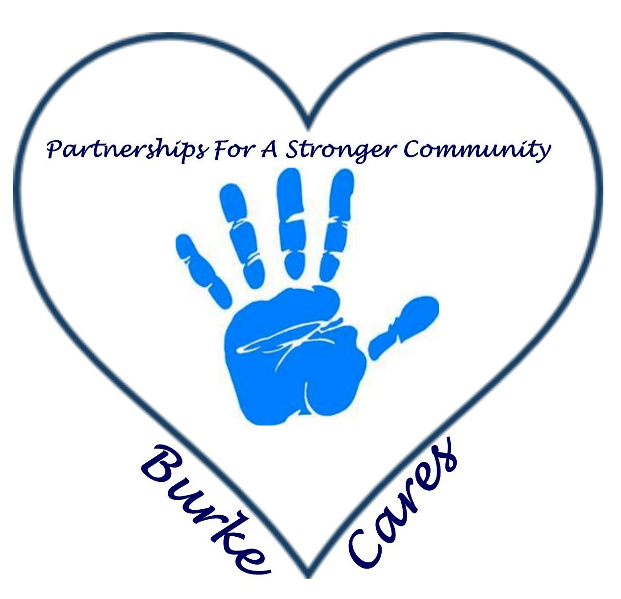
BURKE HOMELESS CONTINUUM OF CARE PARTNERSHIP
August 3, 2016
8:00am
Burke Mission Station
Agenda:

I. Call to Order - Introductions/ Welcome/ Sign In

II. Approval of June and July Meeting Minutes

III. Balance of State
- Regional Restructuring
  - Proposal Approved at June BoS meeting
  - BoS staff have completed an FAQ document regarding restructuring, which is posted at www.ncceh.org/bos/restructuring/
  - The Restructuring Workgroup created a recommended timeline of benchmarks for Regional Committees to stay on track during the restructuring process.
      - June 30: Formation of transition committees
      - July 31: Complete a draft plan for the transition
      - August 31: Present the transition plan to current Regional Committees for approval
      - September 30: Initial meeting of new Regional Committees and election of
Leaders
      - October 1 – 14: One-day regional meetings with BoS staff to create 100-day
Plans Page 2 of 7
      - October 31: Creation of Point-in-Time Count and coordinated assessment
Subcommittees
      - January 1: New Regional Committees formed and meeting

- CoC Program funding Update
  - Presentation for approval for submission of Partners renewal S+C grants
  - Applications due to NCCEH by August 12 – the Steering Committee will review, rank and approve for submission to HUD for funding
  - CoC application due to HUD by September 14
  - Project Review Committees will meet in August need representative
    - August 11 introductory call
    - August 18, 19, 22 one-on-one calls
    - August 26 final call to rank projects

- ESG update
  - Application expected to be released in August due date in September or October
  - We need an ESG lead – email sent to all ESG recipients
  - Info on NCCEH website at www.ncceh.org/bos/esg

- Coordinated Assessment
  - Coordinated Assessment Exchange – Tuesday August 9th 3-4pm – must register to attend
  - Coordinated Assessment Outcomes were due July 15 for April - June 2016

IV. Events Committee
- Point In Time Count
  - Occurred June 16th
    - Outcomes
V. Agency Updates & other Discussions
- GHCCM - Shelter referral for clothing at BUCM clothing store

Adjourn

Next meeting: September 7, 2016 at 8:00am at the Burke Mission Station

