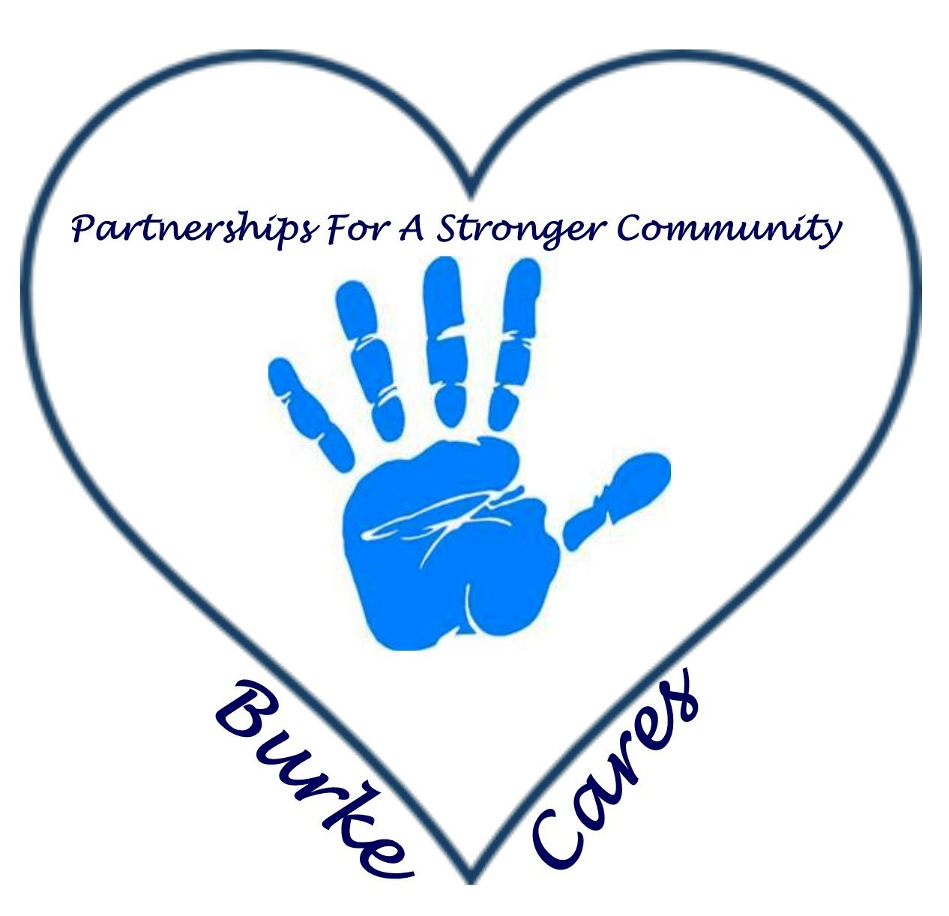
BURKE HOMELESS CONTINUUM OF CARE PARTNERSHIP
February 3, 2016
8:00am
Burke Mission Station

Agenda:

I. Call to Order - Introductions/ Welcome/ Sign In

II. Approval of Meeting Minutes

III. Balance of State
- Coordinated Assessment
  - Changed from VISPDAT Version 1 to Version 2 effective Jan. 1 2016 – please review the training and make sure you are using the correct version
    - Step by Step instructions : http://www.ncceh.org/files/6366/
  - Coordinated Assessment Work Group – Tuesday Feb. 9th 3-4pm – must register to attend

IV. Point in Time Count
- Review
  - Preliminary numbers
  - What worked and what didn’t? How do we improve?

V. Election – Still need a Lead alternate
- 2016 Regional Leads & alternates: Mark your calendars for in-person meeting in Raleigh on Friday, March 4.

VI. Events Committee
- Need committee to work on PIT and HHAW events as well as other events the group would like to work on

VII. Agency Updates

Adjourn

Next meeting: March 2, 2016 at 8:00am at the Burke Mission Station

