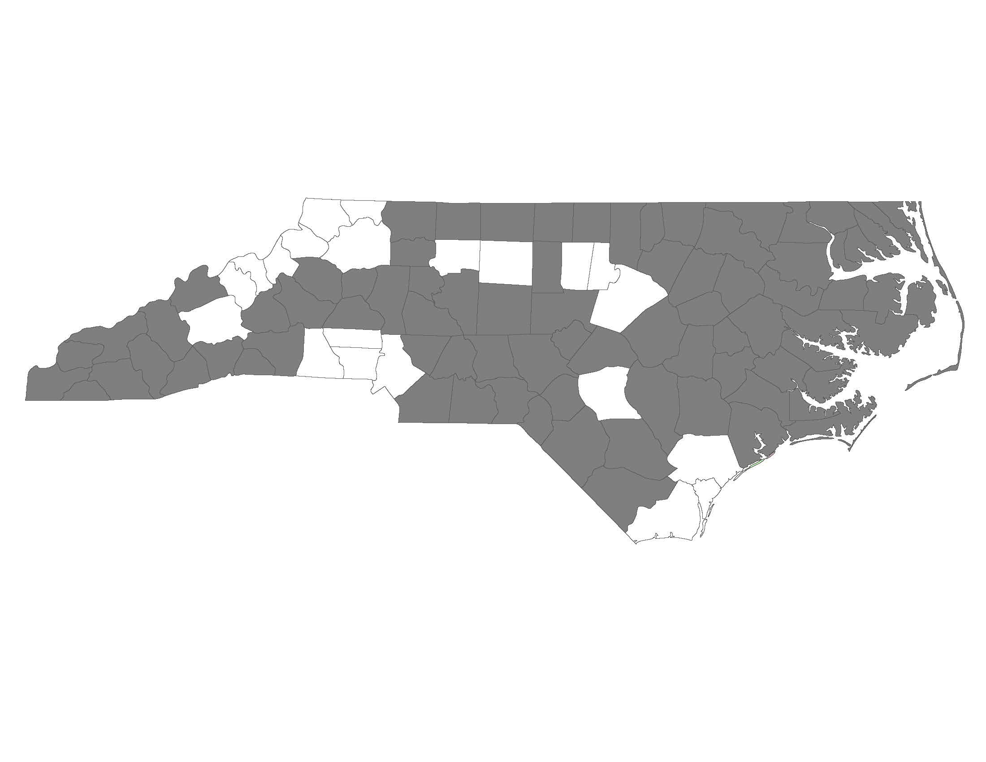

Regional Committee Restructuring Feedback
This form is to be used to provide Regional Committee feedback on the Balance of State Regional Committee Restructuring Proposal. Please complete one form per Regional Committee and submit it by following this link: http://bit.ly/1LRcV2k

Regional Committee:

Name of Person Completing the Form:

Contact Email:

Contact Phone Number:

- What works best about the restructuring proposal?

- What do you anticipate will be the most challenging part of the restructuring implementation?

- How will restructuring affect participation in your region?

If you anticipate a decrease in participation, how would you change the restructuring plan to increase participation?

- Are members of your Regional Committee willing to take a leadership position in the new structure? YES NO
If no, why not?

- Is there another grouping of counties that works better for your Regional Committee?

- What questions do you have after reading the proposal?

- What other ideas or resources do you suggest?

Thank you for your feedback. The Regional Committee Restructuring Workgroup will review all feedback provided by April 30, 2016.
For questions about the feedback form or process, please contact bos@ncceh.org.

