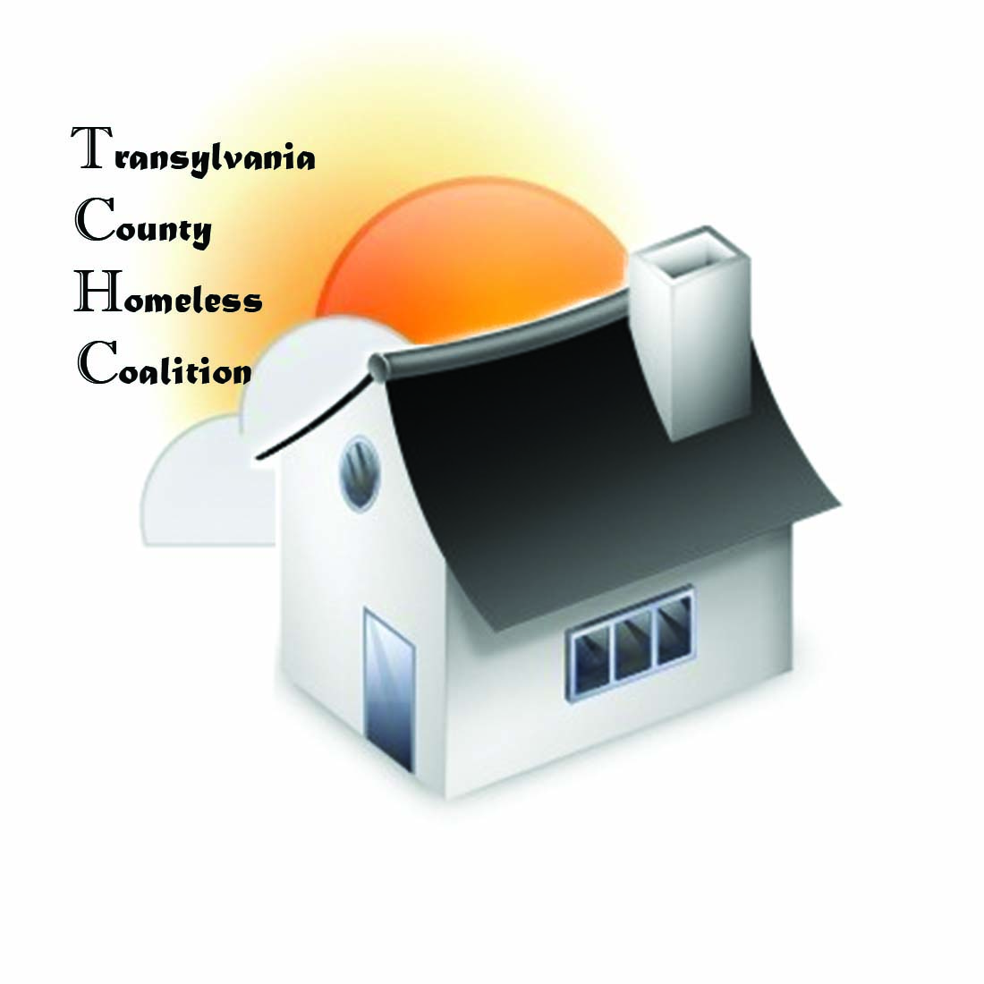
Transylvania County Homeless Coalition
Meeting Minutes
Location: Brevard Housing Authority
133 W. Morgan Street
Brevard, NC 28712
Date: September 3, 2015

Attendees:
Jennifer Molliere, Haven Barbara Marr, TRAIN
Beth Branagan, TCS Ron Schieve, Connect
Ron Schieve, Connect Heather Bradley, TCDPH
Ellen Sizemore, Meridian Shelly Miller, TCS
Amy Uphen, Smoky Mountain Emily Lowery, Haven

- Meeting called to order 9:05 am
- Introductions
- Agency Updates
  - TRAIN- Holding a meeting on privacy practices for Charity Tracker users, Tuesday, September 15th, 9:30 am at Community Services Building
  - Meridian Behavioral Health is hosting a recovery event September 25th more information to follow
  - Smoky Mountain hosting recovery summit at Lake Junaluska September 19th
  - TRAIN holding a transportation meeting on September 18th, looking for help and ideas on grants available. Need data from all agencies, Land of Sky to take over transportation summit from that point.
- Coordinated Assessment has been submitted and sent back, SAFE needs to help with assessment as bulk of funds and referrals come from them
- The homeless information network of NC has a new provider, it is now NCHMIS (North Carolina Homeless Information Network), now consent to enter information in database is implied consent
- ESG application has not been released yet; funds have been extended until the end of the year. Transylvania County has not used all of the funds awarded. We should consider changing our program in order to spend more of the money, and help clients longer. Suggestions, providing rental assistance, may need to include more staff/staff time
- Discussion was made of clients that “budget charity money” and the struggles of case managing folks
- Haven Family House may need to revisit the goals of families and also the time limit allowed to stay, looking at 6 months
- Next Meeting- October 1, 2015
- Adjourned at 9:40am

