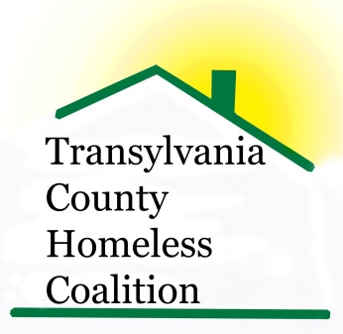
Transylvania County Homeless Coalition
Meeting Minutes

Location: Brevard Housing Authority
133 W. Morgan Street
Brevard, NC 28712
Date: March 5, 2014

Attendees:
Jennifer Flood, Haven (Lead) Shelly Miller, TC Schools
Shawn Miller, Brevard Police Dept. Louise Egerton, THAP
Kaitlin Huggins, TC Dept. of Public Health Ron Schieve, CONNECT
Rhodney Norman, BHA, (Co-Lead) Beth Branagan, TC Schools
Barbara Sorenson, TRAIN Susan Lefler, Community
Emily Lowery, Haven Donna Raspa, Sharing House
Ariana Detoro-Florlenza, VA

- Meeting called to order 9:00am
- Agency Updates
  - Brevard PD- Sean Miller newly trained in mental health, CIT Training
  - TCDPH- HUD, uses McKinney Vento definition of homeless
  - TC Schools – Needs host homes for homeless students, not a part of the foster care system. Families or individuals who would be willing to let a homeless student stay in their home until a more permanent situation could be found.
  - SH- very busy- Getting Ahead Program is up and running, taking referrals
  - CONNECT- Collaboration between school, DSS, The Health Dept. and the Family Place, Children’s Center- to assist families that fall below the bar of CPS and kept out of court
  - TRAIN- moving to work more with agencies on Charity Tracker rather than case management
  - BHA- 7 vacancies 1& 2 BR
  - ESG- Have not received reimbursement
  - Code Purple- program suspended due to non-compliance with the program rules, volunteer safety is priority
  - PIT- compiling data- form keeps changing and new release is has not taken place
  - NCCEH- meeting in March (in-person) Rhodney said he will go
  - Van Watkins memorial service planned for March 20, 2015 at 1 pm
- Meeting adjourned at 9:30 am

