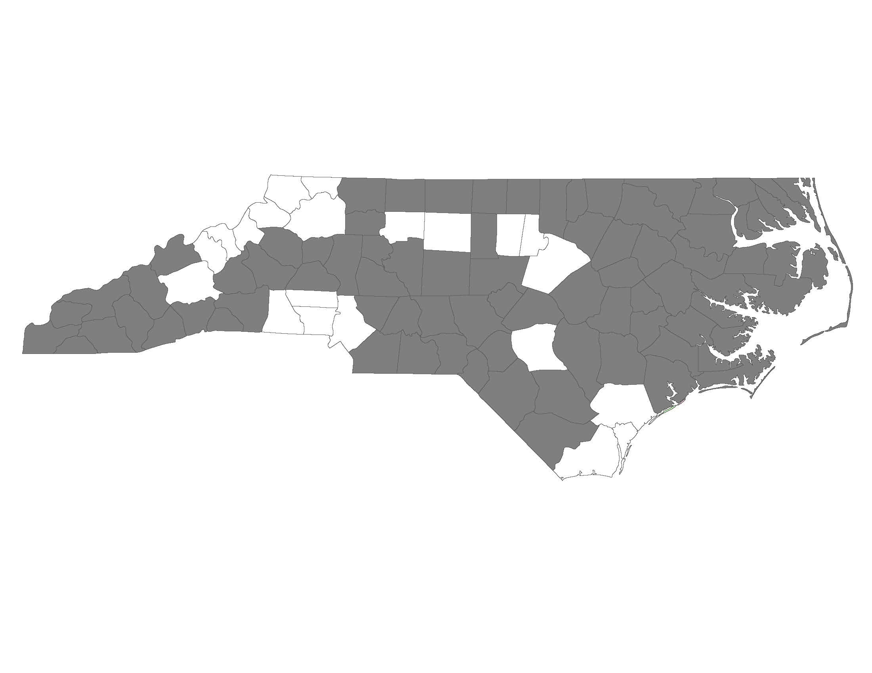

2015 Balance of State CoC Application
New Project Application Review Form for Regional Committees

New project applications are required to be presented to their local Regional Committees for review and approval. Review of applications may be conducted in the manner that the Regional Committee chooses (at an in-person meeting, via email, through a review committee, etc.)

This form certifies that the Regional Committee has reviewed and approved the project application. Regional Committees may also use the form to provide additional feedback about the application. The Project Review Committee will consider feedback provided on this form during their review and ranking of project applications.

The form should be completed and signed by the Regional Lead. If the Regional Lead is from an agency applying for funding in the 2015 CoC competition, the form should be completed by the alternate or another designated representative of the Regional Committee to avoid conflict of interest.

Regional Leads must submit the form to bos@ncceh.org by October 23, 2015. Project applicants should communicate with their Regional Lead to ensure that this form is completed and submitted on time.

Regional Committee and Project Information
Regional Committee:

Applicant Agency:

Project Name:

Project Type (TH, RRH, PSH):

Project Application Review
Applicant agency presented project application to the Regional Committee for review | Yes  No
Regional Committee approves this project for consideration by the BoS Project Review Committee | Yes  No
If no, please explain why:

If yes, what needs will this project address in your community?

If the Regional Committee has any additional comments or feedback about the project, you may provide them here (optional):

Name:

Role (ex. Regional Lead):

Email:

Phone Number:

Signature: ____________________________________________________________________________

Date:

