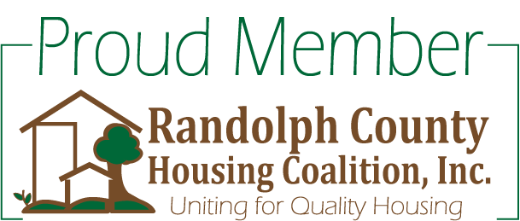

Randolph County Housing Coalition

AGENDA
April 10, 2015

Welcome and Introductions

Approval of Minutes

Old Business

New Business
- Treasury Report by Sarah West
- Coordinated Assessment Update-Debbie Cole

Grantee Updates:
CUOC-Continuum of Care grant
Family Crisis Center-ESG grant
Speaker: Michael Harmon, MPT, CAPS
Senior Life at Home

Committee Reports
- Public Awareness & Membership Committee-John
- Program Services & Goals Committee-Debbie
- BOS-CoC Committee-Debbie
- Housing Inventory Committee-Jeigh
- Home Repair Resources-Wanda
- Hospitality Committee-Pura

Unmet Needs
Round Robin
Adjournment

Next meeting is May 8th at RCSAA at 9:30

