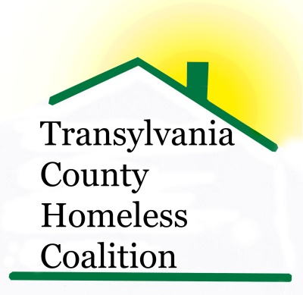

Meeting Minutes

Location: Brevard Housing Authority
133 W. Morgan Street
Brevard, NC 28712
Date: September 4, 2014

Attendees:
Jennifer Flood, Haven Rhodney Norman, BHA
Ron Schieve, Project Connect, WCCA Beth Branagan, Transylvania Cty. Schools
Heather Bradley, TCHD Steve Pulliam, UW
Sarah Lancaster, SMCME/MCO Louise Egerton, ESG Case Manager
Don Rogers, UW/BOL Kaitlin Huggins, TC Health Dept.
Erica Edwards, SAFE Shelly Miller, TC Schools
Sheila Galloway, WCCA Ariana DeToro-Forlenza, VA Center
Susan Lefler, Community Liaison

- Meeting called to order 9:00 am
- Minutes Approved
- Introductions and Agency Updates/New News
  - Haven- Beds available for individuals, Haven Family House is full
  - BHA- Renovations to Pinecrest will update and modernize units
  - TC Schools- New social worker in Rosman schools
    - 141 Homeless children, 15% increase from prior year, 22 pre-school
  - Bread of Life- ice cream social coming up next Saturday 1-4 pm
  - Oxford House- 6 tenants, referrals are appreciated
  - Smoky Mountain Center- available start-up funds for new residents of the Oxford House
    - Have placed one client in Permanent Supportive Housing, through Homeward Bound program
  - United Way- “Stuff the Bus” was success in collecting school supplies. The Brevard High School class of 1964 contributed $1400, toward supplies.
  - WCCA- Section 8 waiting list is moving, wait is now 1 ½ years – 2 years
    - Financial classes will be offered in October, anyone who attends all 3 classes receives a free credit report
  - Project CONNECT- Agency referrals have increased
  - Susan Leffler/Community- She has written some poems about The Haven and they will be featured in “Gutters and Alleyways” a book coming out in October. The book features 10,000 poets for change, more information can be found on Facebook
  - VA- Day of outreach, lunch provided haircuts or homeless veterans October 2nd in Asheville. No transportation will be provided from TC
- ESG Update- No reimbursements have been received
  - Extension was given for ESG application, due on September 9, 2014, will be contacting various agencies for collaboration and MOU’s
- Coordinated Assessment Tool Training- September 17-18, Salvation Army Capital Blvd. in Raleigh, coalition members are encouraged to attend, register by 15th at NCCEH.org
  - Coordinated Assessment Tool will be used to make referrals. The VI SPDAT is a simple tool that assigns client a number, removes the emotion from housing decisions, shows agencies the level of urgency, can be done over the phone
  - The training is on implementation of the coordinated assessment tool in our community
  - Anybody can attend
  - Counties will be grouped based on similarities (i.e. rural vs. urban; shelter vs. no shelter) counties together for training
  - We are fortunate to have the housing authority as a cooperating agency
- HOME Funds- have been awarded, providing Tenant Based Rental Assistance for up to 6 months, combined with ESG funds paying deposits
  - Awarded $52K
  - Must be a client of Meridian, enrolled in Self-Sufficiency at Sharing House, and must attend financial classes with WCCA
- Great report (very large file) available through U.S. Dept. of Housing and Urban Development, Office of Policy Development and Research “Costs Associated with First-Time Homelessness for Families and Individuals”. Contains data that can be used when writing grants, or making presentations. www.HUDuser.org
- Discussion on developing a procedure for emergency housing crisis’ on nights and weekend for local law enforcement, and DSS
  - The Haven is not able to do emergency intakes
  - Overnight volunteers cannot be expected to make those decisions.
- Next meeting scheduled for October 2, 2014
- Meeting adjourned at 9:49

