Piedmont Regional Committee of the Balance of State Continuum of Care
Executive Committee Meeting
June 10, 2014
Meeting Minutes

Opening: The meeting of the Piedmont Regional Executive Committee was convened on Tuesday, June 10, 2014 via conference call led by Floyd Davis of Community Link.
Present:
Nicole Dewitt/ Floyd Davis- Community Link
Melissa McKeown, Union County Community Shelter
David Maulden for Ed Hosack, Cooperative Christian Ministry
Skeet Ayscue/ Salem Taylor, Homes of Hope
David Holston, Rowan Helping Ministries

Approval of Minutes: The May 14, 2014 minutes were approved with corrections.
Balance of State Updates: Prior to the conf call Nicole emailed the Committee the short summary of the June 3rd BoS Steering Committee Conference call. The call focused on the one time ESG fudns that were announced for Emergency Shelter grantees. The ESG application is not out yet, we approved a set of BOS ESG Funding Guidelines. The 1st Draft of the Coordinated Assessment Toolkit was presented. The regional committee is asked to review the packet and provide feedback by June 30. The CHIN Governance Committee is evaluating responses to the RFP- any questions can be directed to Paulette White and or Ellen Blackman. The Data Quality subcommittee and the RRH Subcommittee will meet in June.
PRC Housing Forum Survey results- The housing forum was held on May 20th at All Saints Episcopal Church. The feedback survey was sent out the following day, 17 people responded. The results indicated that most people enjoyed the consumer panel the Housing Simulation Game the opportunity to network and the catering.
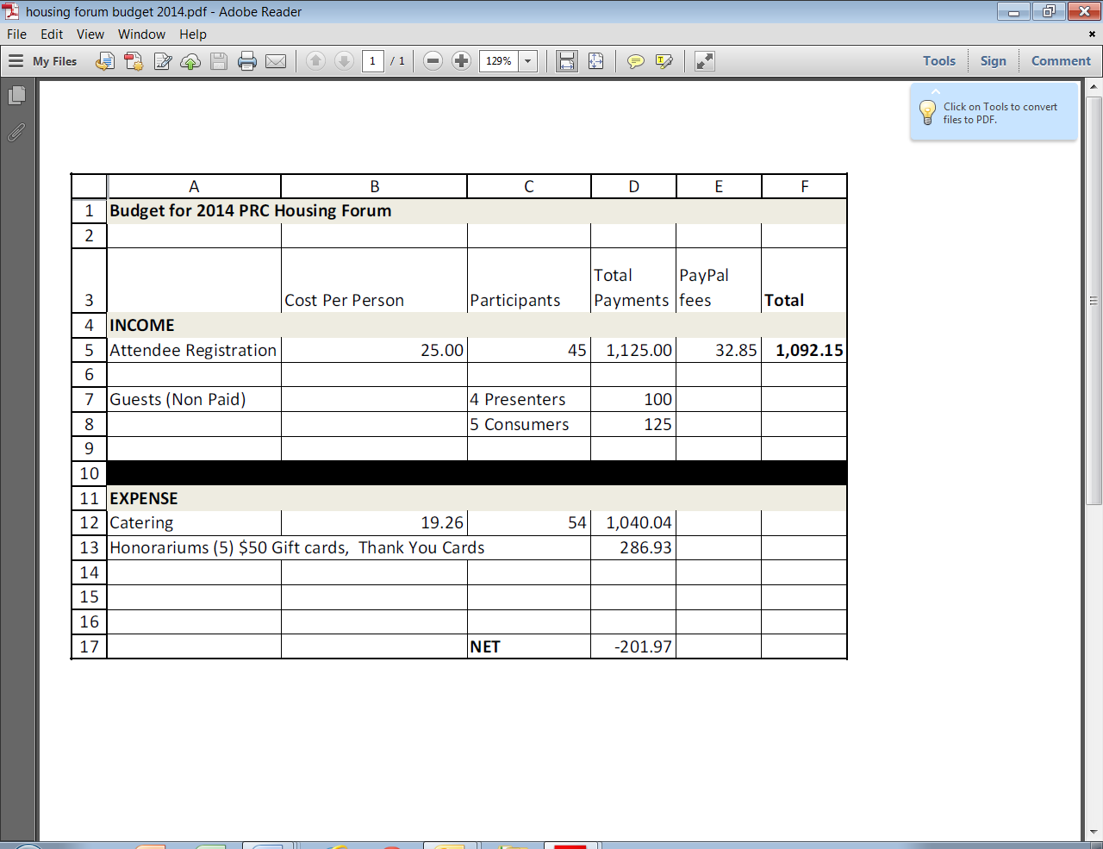
PRC Meeting in Davidson County- June 11, 2014 at the Davidson County Health Department in Lexington NC.
Other Business- none reported

Next meeting is rescheduled for June 3, 2014

