Learn More about Opportunities available to you!

- Find a Job…

- Get Training…

- Access Services…

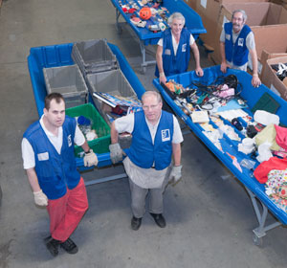
- Get a Career…

Meet with staff and find out
what Goodwill can do for you!

Thursday, March 13, 2014
10:00 am – 12:00 noon
Community Room
Sponsored by the New Reidsville Housing Authority

