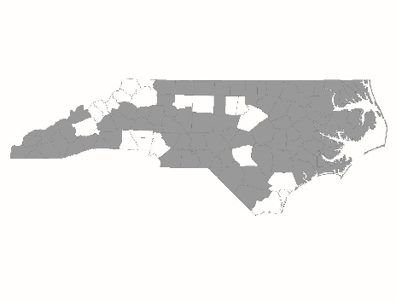

**FY2024 CoC Program Competition**

**New Permanent Supportive Housing Project Applicant**

**Policies and Procedures Page Reference Form**

|  |  |
| --- | --- |
| Applicant: |  |
| Project Name: |  |

**Page References**

The following chart lists program design and other elements that the CoC scores based on documentation submitted by the agency. For each element in the chart, please list the policies and procedures’ page number(s) on which the item appears. Please reference the New Project Scorecard for more details. If the element does not appear in the program’s policies and procedures, mark the cell as N/A. ***All agencies applying for new PSH projects should fill out this form***.

|  |  |  |
| --- | --- | --- |
| **Scorecard Question Number** | **Program Design Element** | **Page Number(s)** |
| 2.2a | Subpopulation targeting |  |
| 2.4 | Eligibility requirements |  |
| 2.4 | Reasons for termination |  |
| 2.5b | Participation in services |  |
| 2.5c | Participation agreement/house rules |  |
| 2.5d | Housing limits |  |
| 2.5e | Service choice |  |
| 2.5f | Service duration/intensity |  |
| 2.5g | Housing choice |  |
| 2.5h | Housing-focused services |  |
| 2.5i | Distinction of housing vs. services |  |
| 3.2 | Employment Services |  |
| 4.4 | Anti-Discrimination Policy |  |
| 4.11 | Client Bill of Rights |  |