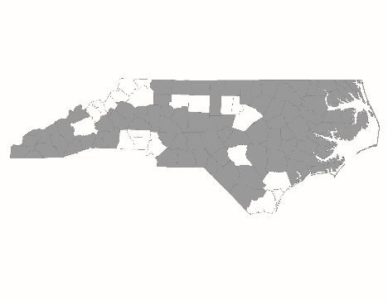

CY2025 Emergency Solutions Grant Appeals Process

The NC Balance of State Continuum of Care (NC BoS CoC) strives to create a fair and transparent process for reviewing and selecting Emergency Solutions Grant (ESG) project applicants. The NC BoS CoC Steering Committee may recommend that some new and/or returning applicants not be included in the final application to the NC Department of Health and Human Services (NC DHHS). To ensure fairness, these projects will have the opportunity to appeal the NC BoS CoC Steering Committee’s decision.

Who may appeal:
- New and returning applicants whose projects were not included in the final slate of Project Applications and approved for submission to NC DHHS.
How to appeal:
- Applicants must submit a letter of appeal signed by a director-level position with any relevant supporting documentation by Friday, August 9, 2024 at 12:00 PM.
- Appeal documentation should be submitted by the deadline using this link.
- Appeals submitted after the published deadline will not be considered.

Appeals must present information that shows the CoC or Project Review Committee made a clear error, did not follow the advertised process, engaged in discriminatory activity, had a conflict of interest, or the grantee experienced extenuating circumstances, as outlined in more detail below. Appeal letters must also address deficiencies in the Project Application. Applications are scored and chosen based on information submitted by the deadline; additional information or explanations to address programmatic deficiencies or missing documentation will not be accepted as part of an appeal.
The Project Review Committee will consider each appeal and decide whether to overturn the decision to exclude the project as part of the final application slate on August 12, 2024.
If the Project Review Committee decides to overturn the decision to exclude the project as part of the final application slate after reviewing appeals, the decision and its reasons must be approved by the NC Balance of State CoC Steering Committee on August 13, 2024. NCCEH staff will email final decisions on appeals to Project Applicant agencies no later than August 14, 2024.

Appeal Decisions:
The Project Review Committee will carefully review each eligible appeal request. The Project Review Committee may, but is not required to, overturn its original decision for the Project Applicant filing an appeal in the following situations:
- The Project Review Committee mistakenly used false or significantly incomplete information to make decisions and additional information presented as part of the appeal letter addresses the deficiencies in the application. The Project Review Committee will not consider appeals that present information that applicants simply neglected to include in its original application, except in extenuating circumstances, outlined below.
- The deficiencies in the Project Application were due to extenuating circumstances that will not affect long-term viability or performance of the project. For instance, the organization experienced a fire that prevented it from completing the application thoroughly.
- The CoC and/or Project Review Committee did not follow the competition process as advertised to the CoC or took steps that are not allowed by HUD policy.
- If an appeal is filed that shows a member of the Project Review Committee has a conflict of interest that affected the Project Review Committee’s decision or a member or members of the Project Review Committee discriminated against the applicant due to the applicant’s race, ethnicity, color, national origin, language, ancestry, religion, sex, familial status, age, gender identity, LGBTQ+ (lesbian, gay, bisexual, transgender, queer/questioning, etc.) status, marital status, interpersonal violence survivor status, or sensory, mental, or physical disability, the Project Review Committee must conduct a new, full review of the application that does not include the member or members with conflicts of interest or who engaged in discriminatory behavior. This full review does not guarantee the Project Review Committee’s original decision will be overturned.

