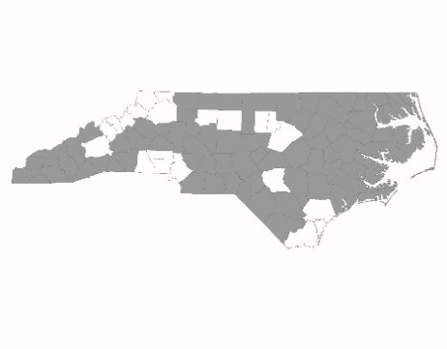

CY2025 ESG Program Annual Allocation - Regional Committee Instructions

On June 11, 2024, the NC Emergency Solutions Grant Office within the North Carolina Department of Health and Human Services (NC DHHS) released a grant opportunity for non-profit agencies and local units of government to provide services designed to assist individuals and families experiencing homelessness or at-risk of becoming homeless. The grant opportunity allows the use of ESG funds for agencies providing Street Outreach, Emergency Shelter, Rapid Rehousing, and Homelessness Prevention services.
One Regional Application and Regional Budget will be completed and submitted by NCCEH staff on behalf of the entire NC BoS CoC’s seventy-nine counties. Regional Committees do not need to complete a Regional Application or Budget.

Agencies interested in applying for ESG Program funds for Street Outreach (SO), Emergency Shelter (ES), Rapid Rehousing (RRH), Homelessness Prevention (HP), and Homeless Management Information System (HMIS) (or comparable database) services according to the NC BoS CoC Written Standards per project type must complete and submit an ESG FY24-25 Project Application (New or Returning) and supplemental materials (see NC BoS CoC ESG Project Application Instructions) to the NC BoS CoC.

NCCEH staff will review applications with the Project Review Committee. The Project Review Committee will create a recommended slate of applications. The NC BoS CoC Steering Committee will approve the final slate of ESG Project Applications within the NC Bos CoC to be submitted to the NC ESG Office at NC DHHS for the CY2025 ESG Annual Allocation.

ESG FY24-25 Annual Grant Application Information is available HERE.
ESG Project Applicant Information and Recommendations
Regional Committees will receive a list of all ESG Project Applicants on a Regional Review Form on July 17, 2024. The Regional Committee should verify each Project Applicant’s participation in Regional Committee and Case Conferencing meetings on this form. The Regional Committee should also indicate whether the Regional Committee recommends each Project Applicant for funding based on participation in the work of the Regional Committee and knowledge of adherence to the NC BoS CoC Written Standards for their application’s project activities. Regional Committees should also indicate why they are or are not recommending the projects for ESG Program funding.

Regional Leads should return this sheet to NCCEH staff by 5:00 PM on July 30, 2024, to bos@ncceh.org. The Project Review Committee will take the information and recommendations into consideration as it develops the final slate of Project Applications recommended to be approved by the NC BoS CoC Steering Committee.

Regional Review Form – to bos@ncceh.org by 5 PM on July 30, 2024

NC BoS CoC ESG Program FY24-25 Annual Competition Timeline

Activity | Date
Request For Applications (RFA) Released by NC ESG Office | Tuesday, June 11, 2024
NC BoS CoC Project Application Instructions Released | Wednesday, June 12, 2024
NC ESG Office RFA Webinar | Friday, June 14, 2024 (New Applicants)  Monday, June 17, 2024  Tuesday, June 18, 2024
NC BoS CoC Webinar for all ESG Project Applicants | Thursday, June 20, 2024, at 10 AM –  PLEASE REGISTER
Project Applications Due to NCCEH | By 5 PM on Tuesday, July 16, 2024
Project Applications Review | July 17 – 30, 2024
Regional Review Form Due to NCCEH | By 5 PM on Tuesday, July 30, 2024
Project Review Committee Selection Meeting | August 2, 2024, at 10 AM
Steering Committee Project Application Recommendation Approval | Tuesday, August 6, 2024, at 10:30 AM
Appeals Due | By 5 PM on Friday, August 9, 2024
Steering Committee Meeting to consider appeals (if needed) | Tuesday, August 13, 2024, at 10:30 AM
Project and Regional Applications Due to NC DHHS | By 5 PM on Monday, August 26, 2024

