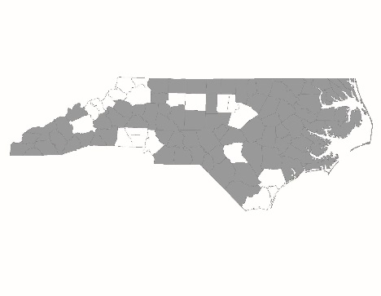

FY2024 CoC Program Competition Pre-Competition Scoring and Standards Review Instructions and Checklist
Agencies must submit information and documents for a Pre-Competition Scoring & Standards Review for Renewal Projects they plan to renew in the FY2024 CoC Program competition by 12 PM on Thursday, May 2, 2024.
Agencies must submit all information to the Smartsheet link per project. Agencies should select the box found at the bottom of the Smartsheet page and enter your email address to receive a copy of your response which will serve as your submission confirmation.
Smartsheet Link: Pre-Competition Scoring & Standards Review Smartsheet Link
For each Renewal Project, applicants must submit:
HUD CoC Grant Number –
This is the number listed on the project’s FY2023 HUD Grant Agreement. Please enter FY2022 HUD CoC grant numbers if FY2023 HUD CoC grant numbers are not available to you by the time you submit this information.
Project Name
The name your agency uses for the project.
Project Type (PSH or RRH)
Select either PSH or RRH from a dropdown menu
Contact Information
Enter the name, email address, and phone number of the person who is responsible for and can answer questions about the project.
Grantee Agreement Form for Renewal Projects
Upload a completed and signed Grantee Agreement Form for Renewal Projects.
CY2023 Annual Performance Report (PDF)
Upload a PDF of the project’s Calendar Year 2023 Annual Performance Report (1/1/2023 – 12/31/2023). CSV files will not be scored. Only submit an APR if your project fully operated in Calendar Year 2023, meaning it was in operation from 1/1/2023 – 12/31/2023.
In HMIS, the CoC-APR report is located under "Provider Reports" on the Reports Dashboard. For instructions on how to pull an APR: https://www.ncceh.org/media/files/page/b4e11bec/coc-apr-guide.pdf
Instructions for pulling the CoC-APR are in the first 5 slides. For the program date range, enter 1/1/2023 – 12/31/2023.
Once the report has been pulled up on the dashboard, agencies should hit CTRL-P to pull up the print function and change the destination to PDF, then hit save.
For DV providers only, agencies should follow the same instructions to run an APR report through their comparable database.
For PSH Projects: Pre-Competition Renewal Applicant PSH Form – CERTIFIED PROJECTS COMPLETE SECOND SECTION ON COORDINATED ENTRY; ONLY COMPLETE FIRST SECTION IF YOU MADE A CHANGE AFTER CERTIFICATION ACHIEVED LAST YEAR
Permanent Supportive Housing applicants should complete and submit this form.
For RRH Projects: Pre-Competition Renewal Applicant RRH Form – CERTIFIED PROJECTS COMPLETE SECOND SECTION ON COORDINATED ENTRY; ONLY COMPLETE FIRST SECTION IF YOU MADE A CHANGE AFTER CERTIFICATION ACHIEVED LAST YEAR
Rapid Rehousing applicants should complete and submit this form.
Program Policies & Procedures – ONLY IF YOU MADE A SIGNIFICANT CHANGE AFTER CERTIFICATION ACHIEVED LAST YEAR
Upload the project’s policies & procedures document.
A Sample Lease – ONLY IF YOU MADE A SIGNIFICANT CHANGE AFTER CERTIFICATION ACHIEVED LAST YEAR
Upload a sample lease.

