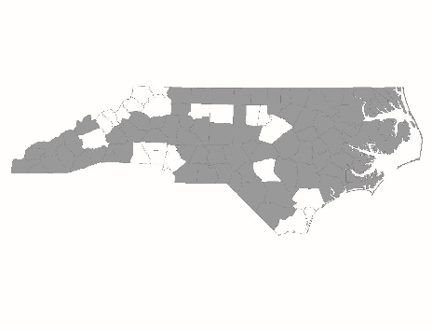

FY2024 CoC Program
Pre-Competition Renewal Applicant
Permanent Supportive Housing Form

PSH Renewal Project applicants are required to complete and submit this form to NCCEH for each individual Renewal Project application by 12 PM on Thursday, May 2, 2024 – ONLY COMPLETE FIRST SECTION IF YOU MADE A CHANGE AFTER CERTIFICATION ACHIEVED LAST YEAR. All grantees should complete the second section on coordinated entry. For agencies that updated policies and procedures, information provided will be used by CoC staff to certify Renewal Project applications for a 3-year term.

Applicant:
Project Name:

Policies and Procedures Page References
The following chart lists program design and other elements that the CoC certifies based on documentation submitted by the agency. For each element in the chart, please list the policies and procedures’ page number(s) on which the item appears. If the element does not appear in the program’s policies and procedures, mark the cell as N/A. If applicants have multiple renewal applications of the same type, they need only fill out this section once.

Scorecard Question Number | Program Design Element | Page Number(s)
3.2 | Eligibility requirements
3.2 | Reasons for termination
3.3b | Participation in services
3.3c | Participation agreement/house rules
3.3d | Housing limits
3.3e | Service choice
3.3f | Service duration/intensity
3.3g | Housing choice
3.3h | Housing-focused services
3.3i | Distinction of housing vs. services
3.5 | Moving-on strategy: participant evaluation
3.5 | Moving-on strategy: formal housing partnerships
3.5 | Moving-on strategy: exit planning
3.5 | Moving-on strategy: linkage to mainstream services
3.5 | Moving-on strategy: aftercare services
3.5 | Moving-on strategy: strategy evaluation
3.6 | Targeting Subpopulations

Coordinated Entry
CE Assessment Scores:
During CY2023, how many new households entered the PSH program?
List the HMIS ID or Comparable Database (CD) ID and corresponding CE Assessment score for each new head of household that entered during the Calendar Year 2023. If comparable database, Highlight CD ID for clarity.
HMIS ID/CD ID: | CE Assessment Score:
HMIS ID/CD ID: | CE Assessment Score:
HMIS ID/CD ID: | CE Assessment Score:
HMIS ID/CD ID: | CE Assessment Score:
HMIS ID/CD ID: | CE Assessment Score:
HMIS ID/CD ID: | CE Assessment Score:
HMIS ID/CD ID: | CE Assessment Score:
HMIS ID/CD ID: | CE Assessment Score:
HMIS ID/CD ID: | CE Assessment Score:
HMIS ID/CD ID: | CE Assessment Score:
HMIS ID/CD ID: | CE Assessment Score:
HMIS ID/CD ID: | CE Assessment Score:
HMIS ID/CD ID: | CE Assessment Score:
HMIS ID/CD ID: | CE Assessment Score:
HMIS ID/CD ID: | CE Assessment Score:
HMIS ID/CD ID: | CE Assessment Score:
HMIS ID/CD ID: | CE Assessment Score:
HMIS ID/CD ID: | CE Assessment Score:
HMIS ID/CD ID: | CE Assessment Score:
HMIS ID/CD ID: | CE Assessment Score:
HMIS ID/CD ID: | CE Assessment Score:
HMIS ID/CD ID: | CE Assessment Score:
HMIS ID/CD ID: | CE Assessment Score:
HMIS ID/CD ID: | CE Assessment Score:
HMIS ID/CD ID: | CE Assessment Score:
HMIS ID/CD ID: | CE Assessment Score:
HMIS ID/CD ID: | CE Assessment Score:
HMIS ID/CD ID: | CE Assessment Score:
HMIS ID/CD ID: | CE Assessment Score:
HMIS ID/CD ID: | CE Assessment Score:
HMIS ID/CD ID: | CE Assessment Score:
HMIS ID/CD ID: | CE Assessment Score:
HMIS ID/CD ID: | CE Assessment Score:
HMIS ID/CD ID: | CE Assessment Score:
HMIS ID/CD ID: | CE Assessment Score:
HMIS ID/CD ID: | CE Assessment Score:
HMIS ID/CD ID: | CE Assessment Score:
HMIS ID/CD ID: | CE Assessment Score:
HMIS ID/CD ID: | CE Assessment Score:

