**Wilson Greene Housing Committee**

**June 18, 2019**

Present: Candice Rountree, Wilson County DSS; Lori Walston, Wilson County DSS; Judi Thurston, United Way; Reverend Marty Stebbins, St. Timothy’s; Cameron Cochran, Wilson Forward; Tony Conner, NC Works; Paula Benson, Wilson Forward; Timothy Rogers, Wilson Housing Authority; John Apol, Hope Station; Shana Baum, Hope Station; Alecia Amoo, Legal Aid; Jocelyn Wilson, Legal Aid; LaTasha McNair, Eastpointe; John Morck, City of Wilson; Lynne White, Wesley Shelter

**Welcome/Introductions**

Attendees were given an opportunity to sign a memory book that will be presented to Mary Mallory’s family.

**Approval of May minutes**

**Balance of State Update**

LaTasha shared that HMIS has been launched with the North Carolina Coalition to End Homelessness. There are changes that must be made to anti-discrimination policies regarding transgender and gender-nonconforming, family separation and faith based activities. There must be grievance and anti-retaliation policies and procedures. This is required for all Emergency Solutions Grantees and Continuum of Care grantees.

The Continuum of Care application process is open and interested agencies would need to complete a notice of intent to apply. Eastpointe is renewing their existing project.

**Coordinated Entry/Assessment**

Meetings occur every Wednesday to complete case conferencing by phone. In order to participate, a shared agreement must be completed and Linda Walling is your contact. [linda.walling@hs-wilson.org](mailto:linda.walling@hs-wilson.org) Linda will share the weekly call information. If you want to make referrals, please consider joining the coordinated entry process.

**ESG**

Shana shared that there are funds available for housing. Please make referrals and follow our coordinated entry process.

**Veterans**

Tony shared that Greenville VA is no longer accepting patients. The van service to Durham is operating.

Tony shared the following after our meeting:

Veterans should look for the below sign posted in the lobby of Network Urgent Care providers:

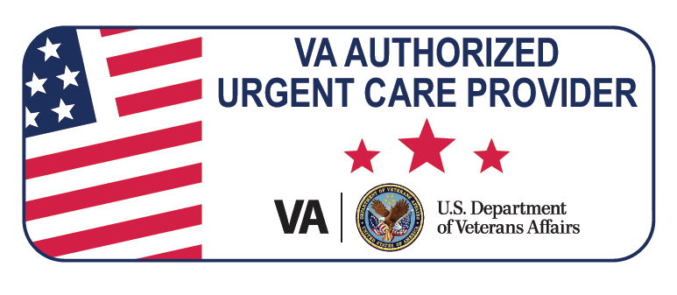

Executive Mission Act Sponsor

<https://vaww.insider.va.gov/MISSION-Act/>

Michael W. Harper, RT(R), MHR, MBA

Assistant Medical Center Director

Fayetteville NC Coastal Healthcare System

2300 Ramsey Street, Rm 106A

Fayetteville, NC 28301

**Leadership of Wilson Wellness Collaborative**

Through a community collaborative process led by Wilson Forward, safe and affordable housing was identified as a goal for our community. One thing we’d like to do is continue to refine and improve coordinated entry, adopt a Housing First model where there are wrap around substance and mental health services provided as well as housing. Candice asked the group if they would be willing to take on this task. Several partners expressed support. A decision was made to form a subcommittee with Candice Rountree from DSS, Tim Rogers from Wilson Housing Authority, Judi Thurston from United Way, LaTasha from Eastpointe, and Lynne from Wesley Shelter.

We also want to address our high rate of evictions. Yolanda from Legal Aid invited a guest speaker from Durham who established an eviction diversion program to speak at our collaborative meeting. The group recommended asking Yolanda if she would be willing to lead this effort. Yolanda’s colleagues in attendance agreed to inform Yolanda of our request.

**Community Partners Updates**

Hope Station – the family shelter, Westview House is scheduled to open in September.

United Way – They receive lots of calls about housing and are invested in addressing this need in the community. West Nash United Methodist donated sleeping mats they made for our street outreach to homeless individuals. They have also donated scarves, hats and gloves for Operation Wrap Up. Judi shared that she has fans if anyone is in need.

We had a discussion about a lack of coordination/communication among those who provide housing assistance. An example was shared that one customer stayed at The Heart of Wilson and received financial assistance from 7 different community partners.

Wesley Shelter – They helped 146 women and children last year and so far, they have exceeded that number and are at 160. It seems like the length of stay is increasing. Some customers are presenting as domestic violence when they really aren’t, customers are no longer receiving open-ended plans unless they are in a crisis, such as a rape victim

DSS – Medicaid transformation is coming soon and Wilson is among the first group of counties to go live. Families who don’t choose a provider will be auto-enrolled, and they have 90 days after that to make a change, this will impact a lot of the families we serve

City of Wilson has an urgent repair program and they are usually able to help 16 -18 with funding of $10,000; they also have a single family rehab program and they are able to help around 5 homeowners up to $30,000. They will take applications in September

Eastpointe – there’s housing available through Permanent Supportive Housing for those who are chronically homeless and living with a mental health diagnosis

Our next meeting July 16th and our facilitator is James Crowell