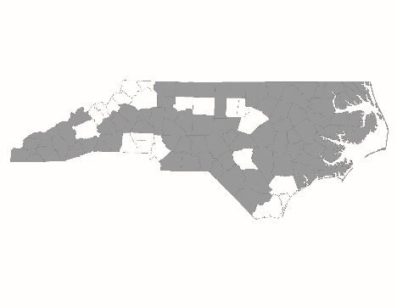

2016 Balance of State CoC Application
Regional Committee Project Application Review Form: New Projects

New project applications are required to be presented to their local Regional Committees for review and approval. This form is required and must be completed by the Regional Lead of the Regional Committee or the Alternate Lead if the Regional Lead is the applicant agency.

Please submit one form for each new project. Forms must be submitted to NCCEH by 5:00 p.m. on Friday, August 12, through this submission link: http://bit.ly/29leTql

Regional Committee and Project Information
Regional Committee:

Applicant Agency:

Project Name:

Project Type (RRH, PSH):

Agency Participation in the Community
Did the applicant participate in 75% of Regional Committee meetings from July 2015 - June 2016? | Yes  No
If no, please explain why:

Did the applicant participate in the 2015 regional ESG application process? | Yes  No
If no, please explain why:

Does the applicant currently participate in or agree to participate in the local Coordinated Assessment process as designed by the Regional Committee? | Yes  No
If no, please explain why:

Project Application Review
Applicant agency presented project application to the Regional Committee for review | Yes  No
Regional Committee approves this project for consideration by the BoS Project Review Committee | Yes  No
If no, please explain why:

If the Regional Committee has any comments or feedback about the project, you may provide them here (optional):

Signature of Regional Committee Lead or Alternate | Date

