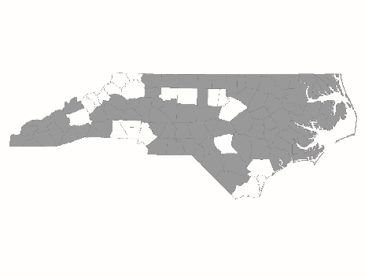
Rapid Re-Housing Program Standards

Applicants must complete this form with information about their Rapid Re-Housing (RRH) program. If an applicant is applying for funding for more than one RRH program, they must complete a separate form for each program.
The answers to the following questions will be used by the Project Review Committee and BoS staff to score the Rapid Re-housing Performance Benchmarks and Program Standards section of the new and renewal scorecards.
Applicant:
Project Name:

Housing Identification
Does the program have dedicated staff whose responsibility is to identify and recruit landlords and encourage them to rent to homeless households served by the program? | Yes  No
If no, do the case manager’s responsibilities include landlord recruitment and negotiation? | Yes  No
Is staff trained in landlord recruitment? | Yes  No
If yes, please describe:
Does your program offer a standard, basic level of support to all landlords? | Yes  No
If yes, please describe:

Rent and Move-In Assistance
Are program staff trained on regulatory requirements of all rapid re-housing funding streams and on the ethical use and application of a program’s financial assistance policies, including, but not limited to, initial and ongoing eligibility criteria, program requirements, and assistance maximums? | Yes  No
If yes, please describe:
Does the program use a progressive approach, where financial assistance is not a standard “package” and is flexible enough to adjust to households’ unique needs and resources, for determining the duration and amount of rental assistance provided? | Yes  No
If yes, please describe:

Case Management and Services
Do program participants direct when, where, and how often case management meetings occur? (The intent of this standard is that program participants are involved in creating a mutually agreed-upon time, place, and frequency of meetings with the case manager.) | Yes  No
Do meetings occur in a participant’s home and/or in a location of the participant’s choosing whenever possible? (The intent of this standard is that program participants are involved in creating a mutually agreed-upon time, place, and frequency of meetings with the case manager.) | Yes  No
Is participation in services voluntary? | Yes  No
Do you have a relationship with employment and income programs to which to refer RRH participants? | Yes  No
If yes, please describe:

Philosophy and Design:
Is program staff trained on the principles of Housing First? | Yes  No
If yes, please describe:
Is program staff oriented to the basic program philosophy of rapid re-housing? | Yes  No
If yes, please describe:
Does your program require participants have income? | Yes  No
Does your program require participants be sober? | Yes  No
Does your program require a commitment to participate in treatment? | Yes  No
If other eligibility requirements exist, please describe:

Program Documentation:
Applicants must attach and submit the following documentation from the RRH program. (Agencies applying for new RRH projects should submit the documentation from their existing RRH program.)

- RRH program eligibility criteria
- Sample lease
- Written policies/procedures for landlord recruitment activities
- Written policy requiring staff to participants basic landlord-tenant rights and responsibilities/requirements of their lease
- Written policies/procedures for determining amount of financial assistance and when case management/financial assistance should continue and end
- Written screening processes for participants

