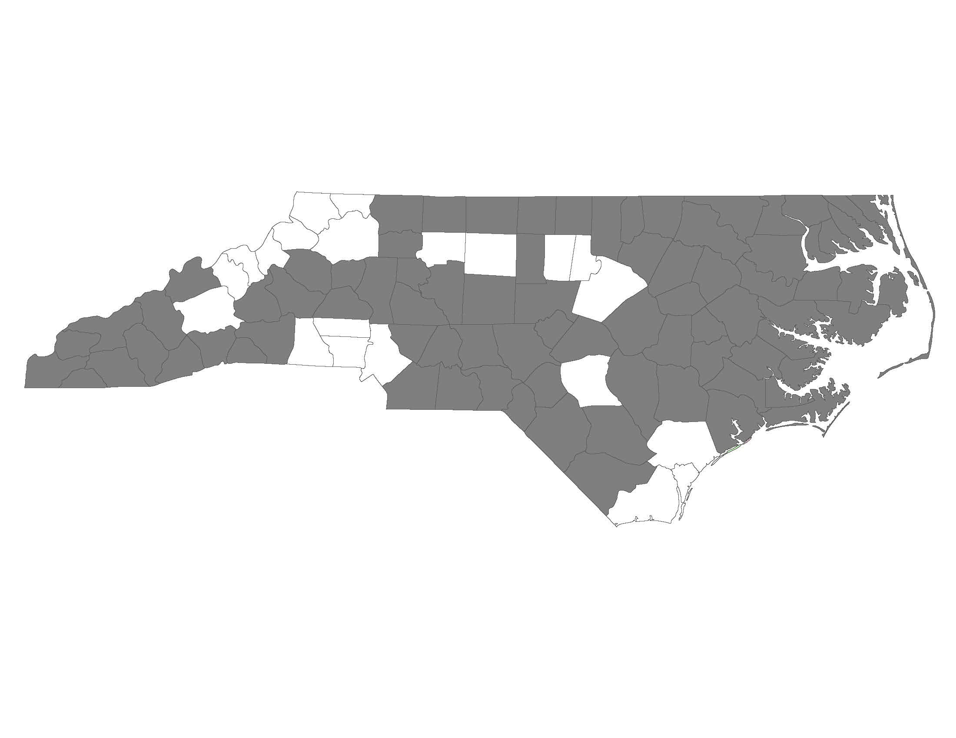
Key Elements of Permanent Supportive Housing

Applicants must complete this form with information about their Permanent Supportive Housing (PSH) grant. If an applicant is applying for funding for more than one PSH grant, they must complete a separate form for each one.
The answers to the following questions will be used by the Project Review Committee and NCCEH staff to score the Key Elements of Permanent Supportive Housing section of the New and Renewal Scorecards.
Applicant:
Project Name:

Please complete the following table regarding services in your PSH program:
Service | Provided? | Provided by: | Optional/  Required: | Are the services able to fluctuate based on participant need?
Assessment of service needs | Provided  Not Provided | Applicant  Other Provider | Optional  Required | Yes  No
Assistance with moving costs | Provided  Not Provided | Applicant  Other Provider | Optional  Required | Yes  No
Case management | Provided  Not Provided | Applicant  Other Provider | Optional  Required | Yes  No
Child care | Provided  Not Provided | Applicant  Other Provider | Optional  Required | Yes  No
Education services | Provided  Not Provided | Applicant  Other Provider | Optional  Required | Yes  No
Employment assistance and job training | Provided  Not Provided | Applicant  Other Provider | Optional  Required | Yes  No
Food | Provided  Not Provided | Applicant  Other Provider | Optional  Required | Yes  No
Housing search and counseling | Provided  Not Provided | Applicant  Other Provider | Optional  Required | Yes  No
Legal Services | Provided  Not Provided | Applicant  Other Provider | Optional  Required | Yes  No
Life skills training | Provided  Not Provided | Applicant  Other Provider | Optional  Required | Yes  No
Mental health services | Provided  Not Provided | Applicant  Other Provider | Optional  Required | Yes  No
Outpatient health services | Provided  Not Provided | Applicant  Other Provider | Optional  Required | Yes  No
Outreach services | Provided  Not Provided | Applicant  Other Provider | Optional  Required | Yes  No
Substance abuse treatment | Provided  Not Provided | Applicant  Other Provider | Optional  Required | Yes  No
Transportation | Provided  Not Provided | Applicant  Other Provider | Optional  Required | Yes  No
Utility deposits | Provided  Not Provided | Applicant  Other Provider | Optional  Required | Yes  No

Describe how case management is provided for participants in your program.
Is case management provided by your agency or another provider? What types of services do case managers provide? What happens if a program participant does not want to work with a case manager?

What happens if a program participant needs an increased level of services than they are currently receiving?

What happens if a program participant needs a decreased level of services than they are currently receiving?

What is the normal workflow for a program participant from engagement to one year in housing?
Be sure to include how the program determines eligibility, engages the participant, develops a service plan, locates housing, and provides ongoing services.

Please attach and submit:
- PSH program eligibility requirements
- a sample lease
- program rules (if any). If the program has none, please state so here:
- house rules (if any). If the program has none, please state so here:

