North Carolina Homeless Management Information System (NC HMIS)
Amendment to Contract

This Agreement, made this day of ______ , 2015, constitutes an amendment to the Contract for Transition Services between the Michigan Coalition Against Homelessness, Inc. (“MCAH”) and ______________________________________.

Whereas, MCAH and _________________________ entered into a Contract for Transition Services (“Contract”) dated ______________; and

Whereas, MCAH and ___________________________ desire to amend the Contract to extend the term, increase the Contract amount and modify the scope of work to include additional services.

Now therefore, for the above-state purposes, and in consideration of the covenants and conditions herein contained, MCAH and __________________ do hereby agree as follows:

- Section II of the Contract shall be modified to read as follows:

“The term of the Contract will be January 1, 2015 through September 30, 2015. Notwithstanding these dates, the Contract shall expire upon completion of the work program contained in the Scope of Work (Exhibit A) and the Quarterly Scope of Work (Exhibit A-1) or disbursement of all Contract funds shown in the Transition Budget (Exhibit B) and First Quarter Budget Budget (Exhibit B-1). Any extension of this Contract is dependent upon funding availability, a satisfactory review of services provided, and agreement of the parties.”

- Section IV of the Contract shall be modified to read as follows:

“_____________________ will pay MCAH an amount not to exceed XXXXX THOUSAND XXX HUNDRED XXXX AND XX/100 DOLLARS ($XXXXXX) for services performed as described in the Scopes of Work (Exhibits A and A-1) and expenses incurred, consistent with the Transition Budget (Exhibit B) and First Quarter Budget (Exhibit B-1) in a share of costs agreed upon by formal action of the NC HMIS Governance Committee, with the share of transition costs shown in Exhibit C and the share of first quarter costs shown in Exhibit C-1 and the share of total amended costs shown in Exhibit C-1. MCAH may shift funds between categories of expenditures in Budgets B and B-1, respectively, as long as the shift does not exceed 10 percent of the Grand Total of Estimated Costs in the respective budget. Costs may include but are not limited to the cost types shown in the budgets. However, funding for types of costs other than those specifically shown in the budgets must be approved by formal action of the NC HMIS Governance Committee.”

- Section VI of the Contract shall be modified to read as follows:

“MCAH’s point of contact for all issues (technical and otherwise) specified in the document is Eric Hufnagel, 15851 S. Old US27, Building 30, Suite 315, Lansing, MI 48906, email ehufnagel@mihomeless.org. The point of contact for ________________________for purposes of contracts and invoices is __________________________________________________________________. The point of contact for ______________________ for all other matters is ___________________________________________________________________.

- Exhibit A of the Contract shall be modified by inserting Exhibit A-1, which is attached hereto, at the end of Exhibit A.

- Exhibit B of the Contract shall be modified by adding Bowman System Fees and Services as an eligible activity under System Tasks.

- Exhibit B of the Contract shall be further modified by inserting Exhibit B-1, which is attached hereto, at the end of Exhibit B.

- Exhibit C of the Contract shall be modified by inserting Exhibit C-1, which is attached hereto, at the end of Exhibit C.

- Except as modified herein, all conditions of the Contract are incorporated herein by reference and shall continue in full force and effect to the completion of the Contract.

IN WITNESS WHEREOF, the parties hereto have caused this agreement to be executed in duplicate by their duly authorized representatives and signed under seal effective as of the date first written above.

MICHIGAN COALITION AGAINST HOMELESSNESS, INC.

BY:_____________________________________________(SEAL)
Eric Hufnagel, Executive Director

Signed: ________________________________ Date: __________________

CoC Representative:______________________ Title:_________________

STATE OF NORTH CAROLINA
________________________ COUNTY
I, , a Notary Public of ___________________________County, NC, do hereby certify that _________________________________ personally came before me this day, and acknowledged that he or she is the ______________________________ of ____________________________________ and that by authority duly given and as the act of the corporation, the foregoing instrument was signed in its name by its ______________________________, sealed with its corporate seal, and attested by him or her as the ______________________________.

WITNESS my hand and official seal, this the ______ day of ___________________, 20___.

_______________________________________
Notary Public

My commission expires: ___________________________________

Acknowledged by before me on the day of ,
Signature______________________________________________
Printed name___________________________________________
Notary public, State of Michigan, County of
My commission expires___________________________________

Exhibit A-1
Quarterly Scope of Work for the North Carolina HMIS (NC HMIS)
July 1, 2015 to September 30, 2015

First quarter activities* for July 1, 2015 to September 30, 2015 are shown in context of the annual scope of work for the year beginning July 1, 2015 and ending June 30, 2016.

 | Timelines**
Specific Activity | MCAH | NC Partners (Specific Partner)
Administrative Tasks
*CoCs set schedule for signing Participation Agreements & Admin QSOBAA |  | 7/15/2015 (CoCs)
*Final FY15/16 Contract & Scope of Work Adopted |  | TBD/2015 (Governance)
*Final FY15/16 Contract & Scope of Work Signed and Executed | 9/30/15 | 9/30/2015 (CoCs)
*--Draft Contract |  | TBD/2015 (Governance)
*--Draft Scope of Work | 6/10/2015 (This Document)
*Invoicing with associated Activity Report (15 days from close of Month) | 8/15/2015 | Payment Invoice + 30 calendar days (CoCs)
HMIS P&P Update
--Draft Update | HUD + 45 days or April 30th
--CoC Adapts and Adopts |  | Draft + 60 Days (CoCs)*
--Mid-Year Review and adapt Scope of Work as necessary | 1/15/2016 | 1/15/2016 (Governance)
Negotiate FY16/17 Bowman budget | 4/15/16
FY16/17 Budget, Contract & Scope of Work Adopted |  | 4/30/2016 (Governance)
--Draft Scope of Work | 3/30/16
--Draft FY16/17 Budget | 3/30/16
--Draft Contract | 3/30/16
FY16/17 Contract & Scope of Work Signed and Executed | 6/30/16 | 6/30/16 (CoCs)
NC HMIS WEB Site (Based on final payment for transition tasks)
*--Branding | Branding Options  completed | 7/1/2015 (Communications)
*--Functionality Presentation | Payment + 21 days | Presentation + 10 days – Approval (LSAs)
--Content moved from Interim WEB Site - Live Web Site | Payment + 90 days
--Web Site Satisfaction Survey (LSA) | 90 days after Launch
Training--Our obligation is to train
*Certification Library of basic training (see Certification Training Schedule): | 7/1/2015 Ongoing
*LSA Meetings | 7/1/2015 Ongoing
*Agency Administrator Meeting | 7/1/2015 Ongoing
*Help Desk | 7/1/2015 Ongoing
Compliance Audit Plan (with LSAs) & Training Tools | 10/31/2015 | Approval 11/30/2015 (LSA)
*HMIS APR Overview with CoC Grantees (scheduled as requested by CoCs). This is a training with grantees to walk through the APR, discuss content and make assignments. | 1 | Grantee End Date +/- 10 (CoCs)
*NOFA / AHAR / HIC & PIT Training Plan | Guidance Release+ 15 Days
LSA Training Satisfaction Survey | 12/15/2015 & 6/15/2016
Systems Tasks
*Finish moving all Licenses | Migration +30 day | May be renegotiated if LSA is not available
*Negotiation Funder Workflows as needed (Funder approval) | Approval + 30 days
*HMIS System Statistics for HMIS CoC Grants | HMIS Grant End Date + 30 Days
Measurement Issues
*Initial Coverage Training + Schedule with CoCs | Training by 10/1/15 | CoC completed exercise by 3/31/16 (LSAs)
Chronic Certification Working Group Draft Plan | 2/28/16 (LSA Group) | 2/18/2017 LSA completed
Annual Report (meeting to discuss whether we are ready to publish and develop plan for publication if it’s a “go”). | 4/1/2016 | Plan Completed 6/1/2016  (Reports Committee)
Reports
*Move MCAH Suite of Reports (w/out SOW) | 7/1/2015
Bowman SOW Reports – Bowman Execution Date
*Manage & Update Reports | 7/1/2015 ongoing
*Custom Reports as Negotiated | Negotiation Complete +30 days for initial draft unless otherwise negotiated
*Add Bowman Reports to the Site (if request is involved, we will move report within 5 days). | 7/1/2015 ongoing
*Activities occurring partially or completely in first quarter of annual period
**All days are defined as “work days” unless otherwise specified.

Exhibit B: MCAH NC Transition Budget
Category and Activities: | Hours | Estimated Costs | Completion Date
Governance | 60 | 4,200.00 | 4/30/2015
-Interim Budget
-Interim MOU
-Year 1 Budget Finalized
-Reporting P&P Finalized
-Year 1 Contract
-HMIS Policies and Procedures
Communication Plan | 15 | 900.00 | 1/31/2015
-Develop Calendar of Governance Meetings
-Negotiate content for initial LSA Meetings
-Develop Calendar for LSA & User Meetings
-Develop Calendar of Trainings (See Training)
-Develop Communications Contact Lists
Privacy Plan | 40 | 7,800.00 | 4/30/2015
-NC Consultant Fees |  | 5,000.00
-Negotiation/Approval of new Privacy Plan | 10
-Develop Revised Agreements (Particpation, QSOBAA, etc) | 20
-Develop Client Releases / Notices etc | 10
System Tasks (mix of Bowman and MCAH) | 77 | 16,750.00 | 6/30/2015
-Update Contract with Bowman (MCAH & Governance) | 5 | 350.00
-Server Evaluation (Bowman) |  | Normally Free
-Evaluate and add new Modules | 4 | 240.00
-Develop / Approve Archive & Data Reorganization Plans | 20 | 1,200.00
-SOWs with Bowman (Archive, move data and reports) | 8 | 10,560.00
-Build / modify Reports on NC HMIS @ $110/hr | 40 | 4,400.00
-Bowman System Fees and Services |  | TBD
Training (MCAH Staff) | 123 | 7,460.00 | 31-May
-Administrative Pages (20 1 hour Sessions) | 25
-Visibility and Security (20 1 hour Sessions) | 25
-Module Training (current and new - Live via WEB/Recorded) | 30
-Privacy (8 hrs Live via WEB) See April for on-site | 8
-Help Desk related to above training (Jan to April) | 25
-Reports (5 - 1 hour Sessions via Web) | 10
On Site Staffing (Mid March to June 30th) |  | 79,677.46 | 6/30/2015
-Recruiting | 13 | 810.00 | 2/28/2015
-1 Staff FTE (mid-March to June 30) |  | 23,625.00
-.5 Staff FTE (April - June 30) |  | 3,833.33
-Office Expenses + Equipment & Supplies |  | 7,291.67 | April ongoing
- Equipment (2 computers, 1 printer, 1 tablet, 2 headsets) |  | 4,100.00
-Internet + GoToMeeting+Office Supplies |  | 3,837.46
-Visiting MCAH Staff (April to June includes Housing/Car Stipend) |  | 36,180.00
Travel Expenses (Air+Hotel+Car+Hours Spent on Site) |  | 20,901.75 | 6/30/2015
-Jan (1 trip, 2 staff, 2.5 days) Travel Expenses |  | 1,761.00
-On Site Staff hrs for Barb and Gerry | 32 | 2,080.00
-Feb (Barb 2 trips 2 days; Gerry 2 trips, 3 days ) - Governance + Interviews |  | 2,988.00
- Total 5 days - 40 hours (Barb 16, Gerry 24) | 40 | 2,560.00
-Mar (1 5-day trip, 1 staff to NC, 1 5-day trip NC staff to Michigan) |  | 3,041.50
-Michigan on-site hrs = 40, New hire billed elsewhere | 40 | 2,400.00
-April (1 trip 5 days) Barb - Gerry is housed in NC. |  | 1,270.75
- Barb meets w each CoC & trains privacy | 40 | 2,800.00
-May (1 trip 1 staff, 2.5 days) (Gerry is housed in NC) |  | 880.50
-Barb at Governance Meeting | 16 | 1,120.00
Administrative (Jan to April) |  | 7,500.00 | 4/30/2015
-Payroll & Budget & Executive Director | 45 | 2,700.00
-Planning and Governance Meetings | 80 | 4,800.00
Full Support Operations beginning on May 1,2015 (2 months) |  | 20,160.65 | May ongoing
-Training Development and initial training delivery (front loaded) |  | 6,123.12
-Help Desk (prorated from Annual Budget) |  | 3,126.24
-Project Based Admin Support (2 months) |  | 6,604.02
-Insurance, audit, payroll, financial services, licenses (front loaded) |  | 4,307.27
Grand Total: |  | $165,350 | 6/30/2015
Notes (See Application Budget for Detail on Expenses):
-Hourly Rates: Barb @ $70/hr, Analyst Wk @$110/hr, All other at $60/hour
-$10,000 Bowman and $5,000 for Privacy Expert were included.
-$81,000 Salary + Benefits prorated.
-Staff and Space Costs were prorated from the 25k estimate in Application budget
-Travel Expenses (8 hrs per day per staff, Airfare estimated at $450,Car Rental = $50/day + .55/mile mileage (assumes 25 miles rtrp to airport), hotel per diem=$97/day, food/expenses perdiem = $56/day. Travel day is .75 day.
-Any additional trips will be negotiated on a cost/trip basis.
-Training will be intensive the first 4 months. $9120 was split - half in May and June. $9360 prorated

Exhibit B-1
First Quarter Budget
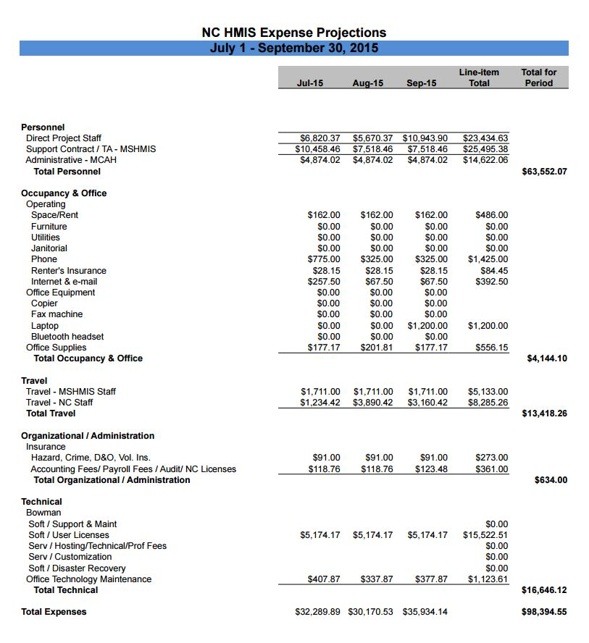

Exhibit C-1
Transition, First Quarter and Total Amended Costs

Continuum of Care (CoC) |  | 2014 HIC |  | MCAH Costs + Bowman Monthly Fees
 |  | # Beds | Percent of total | First Quarter (July-Sept 2015) | January -June 2015 transition costs | Total Amended Costs Jan-Sep 2015
500 | Forsyth | 1,047 | 5.76% | $5,668.49 | $14,692.88 | $20,361.37
501 | Buncombe | 1,138 | 6.26% | $6,161.16 | $15,969.92 | $22,131.08
502 | Durham | 1,189 | 6.54% | $6,437.28 | $16,685.61 | $23,122.89
503 | Balance of State | 5,242 | 28.84% | $28,380.34 | $2,945.51 | $31,325.85
504 | Guilford | 1,338 | 7.36% | $7,243.97 | $18,776.58 | $26,020.55
505 | Mecklenburg | 3,865 | 21.27% | $20,925.22 | $35,164.40 | $56,089.62
506 | Tri-HIC | 666 | 3.66% | $3,605.74 | $9,346.19 | $12,951.93
507 | Wake | 2,138 | 11.76% | $11,575.19 | $30,003.23 | $41,578.43
509 | Gaston-Lincoln-Cleveland | 614 | 3.38% | $3,324.21 | $8,616.46 | $11,940.67
511 | Cumberland | 498 | 2.74% | $2,696.19 | $6,988.59 | $9,684.78
513 | Orange | 231 | 1.27% | $1,250.64 | $3,241.70 | $4,492.34
516 | Northwest | 208 | 1.14% | $1,126.12 | $2,918.93 | $4,045.05
Overall |  | 18,174 | 100% | $98,394.55 | $165,350.00 | $263,744.55

Notes: The monthly Bowman Systems costs are included in the MCAH budget. The initial additional annual Bowman Systems cost was paid for outside of these budgets by Mecklenburg CoC and Balance of State CoC. The Balance of State's January-June cost is lower than the percent of total because the CoC paid more than its share (the total annual Bowman cost minus Mecklenburg's share).

