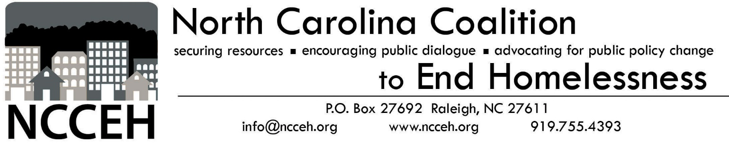

Supportive Services Only-Coordinated Entry Regional Grants
  - 2019 Renewal Application

Application Check List
Refer to NCCEH’s Coordinated Entry Regional Grants Request for Proposals for more information about application requirements, grant requirements, and program design.
Project Description
Complete written application (below)
Match letters documenting 25% match to all requested funds
If expanding to serve additional regional committees: Letter of support from the Regional Committee committing to elect the applicant agency as Coordinated Entry Lead, if it is awarded SSO-CE funds
Agency Grant Management Documents
Approved SSO-CE corrective action plan for any monitoring findings during the 2018-2019 grant year.
Detailed budget spreadsheet, available here
Agency Board of Directors Roster
Board of Directors member roster that includes name, organization, and contact information of each board member

Submission Directions
Submit a complete application, with all the required documents to http://bit.ly/SSOCE2019 by August 1, 2019 at 6:00pm.

One agency may apply for funding in multiple Regional Committees. The applicant agency must submit all Project Description documents, outlined above, for each Regional Committee for which they are applying, but may submit only one set of Agency documents.

Applications missing any of the above materials, without answers to any of the written questions, below, or submitted after the deadline will not be accepted.
Any questions about this application or the SSO-CE program should be sent to bos@ncceh.org.

NCCEH SSO-CE Renewal Written Application

Section 1. Organization Information

Project Applicant Information
Name of organization:

Street address: | Mailing address:
Telephone: | Website:
Federal tax ID number: | DUNS #:
Select organization type: | Date of incorporation:  mm/dd/yyyy

Certification
To the best of my knowledge and belief, all information in this application is true and correct.
Name of authorized official | Title of authorized official
Signature |  | Date

Area Served
- Which Regional Committee will you serve with this funding?

Section 3. Staff Capacity

Staff Information
- Enter the # of part-time CE staff:
- Enter the # of full-time CE staff:

- Please describe your plan to staff coordinated entry with this grant. Include how many staff will be involved and what activities each of them will cover. Please identify which staff member will be the Coordinated Entry Lead for the Regional Committee you plan to cover with this grant. Please also indicate if your agency plans to hire new staff to support coordinated entry in 2019. Limit answers to 2,000 characters or less.

HMIS
- Please attach a 0640 HUD Data Quality Report for calendar year 2018. Run the report for your full agency.

Section 4. SSO-CE Project

SSO-CE Project Budget Request and Match
Please attach the detailed project budget request spreadsheet. Grantees must spend their grants based strictly upon the funding requested in each category. Agencies will need to submit a budget amendment to NCCEH to change the amount to be spent per category.

Please attach letters documenting 25% match to all requested funds.

1. Please describe a plan to secure additional funding to support coordinated entry in your region, for your organization, to support other organization’s CE work, or both.

SSO-CE Project Description
The following questions apply specifically to the SSO-CE funding for which you are applying.
- Please describe the full scope of the project for which your agency will use the funding. Be sure to describe which gaps in your coordinated entry system you plan to fill using this funding, and how this funding will improve your coordinated entry system. Limit answers to 4,000 characters or less.

- What are the challenges your Regional Committee is facing in implementing coordinated entry? What steps have you taken to start solving those problems? What steps do you plan to take during the 2019-2020 operating year? What changes are you planning to make in your current SSO-CE grant to help address these challenges? Limit answers to 2,000 characters or less.

- Answer only if you are applying to cover additional regions than the area you covered with the 2018-2019 grant: What challenges did you face in 2018-2019 that will affect how you implement an SSO-CE grant in a new Regional Committee? What did you learn and what will you do differently?

- How do you plan to improve diversion from homelessness in your Regional Committee in 2019? Limit answers to 2,000 characters or less.

- How you will you improve the process of maintaining the CE prioritization waiting list and referring households to housing resources in 2019? Limit answers to 2,000 characters or less.

- Please describe how people in domestic violence shelters gain access to the CE system in your Regional Committee. What process do you have to share information, and what challenges have you faced integrating the DV system into coordinated entry? What steps are you planning on taking in 2019 to increase access to CE for people in DV shelters? Limit answers to 2,000 characters or less.

- Please describe how you will use the requested funding to expand access to coordinated entry for underserved groups, particularly people living unsheltered and people in shelters that are not currently participating in coordinated entry. Limit answers to 2,000 characters or less.

- If you plan to carry out activities using matching funds that are eligible SSO-CE activities that do not fall under one of NCCEH’s SSO-CE budget categories (annual assessment of service needs, case management, or outreach), please describe those activities below. See NCCEH’s SSO-CE RFP for more information about eligible uses of match. Limit answers to 2,000 characters or less.

- Please describe your plan to spend all SSO-CE funding within one year. If you did not spend at least 90% of your funding in 2018-2019, please describe what you will change this year to spend at least 90% of your funding. Limit answers to 2,000 characters or less.

